**Saaipranav Subramanian  
Convergepoint  
Form Submission – Employee Home Page**

Contents   
Introduction...................................................................................................................2  
Empathize .....................................................................................................................2  
Define ...........................................................................................................................4  
Iteration 1- Low fidelity MVP............................................................................................6  
Iteration 2- Mid fidelity MVP.............................................................................................8  
 Guerrilla Usability Testing...................................................................................9  
Iteration 3- High fidelity MVP..........................................................................................11  
Figma Links ……………...................................................................................................13  
References .. …………...................................................................................................13  
  
  
  
  
  
  
  
  
**Introduction**-

The goal of this web application is to develop a user-friendly and easily understandable User Interface for the ConvergePoint Disclosure Portal. The portal is a software application used by employees of companies to complete annual disclosures and access relevant information and instructions.

The design thinking approach I used is a human-centered methodology that focuses on understanding user needs, brainstorming creative solutions, and constantly reworking the prototype based on those solutions from user feedback. By using this approach, I aim to create a UI that targets to the specific needs of the disclosure process for all employees.  
  
  
  
**Empathize// Seeing through the User’s eyes**-

The goal here is to understand the web application through the target audience’s eyes; the employees To gather information, I went through blog posts on reddit and google reviews of existing disclosure software   
  
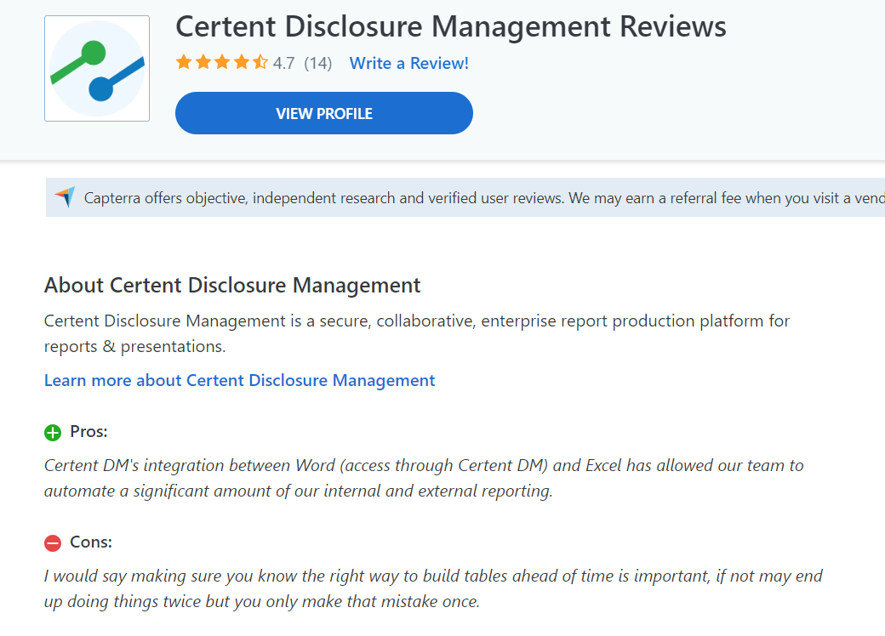 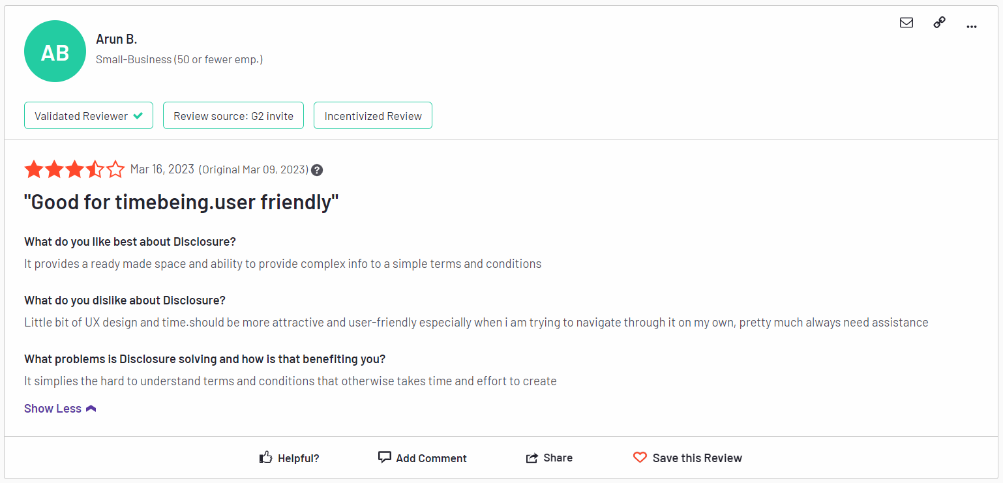

Figure 1; Cenet Review

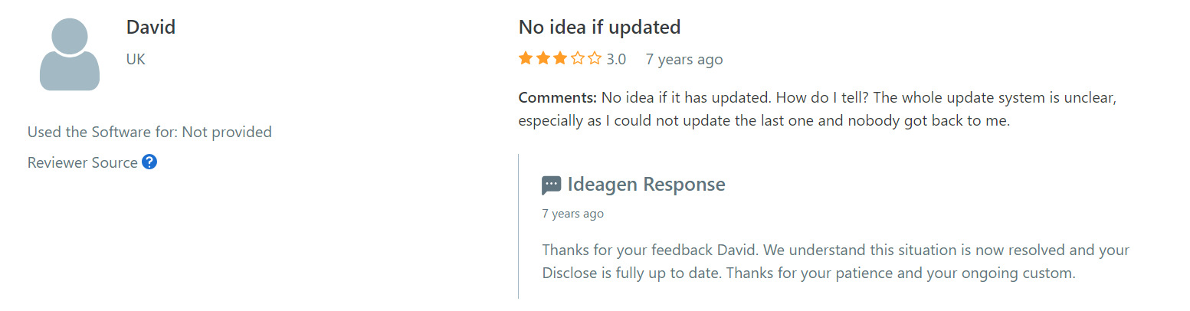 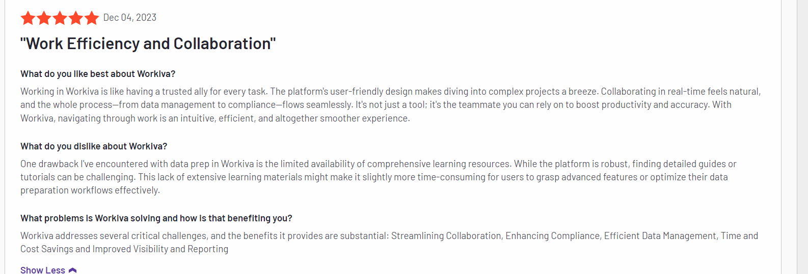

Figure 2; ideagon review

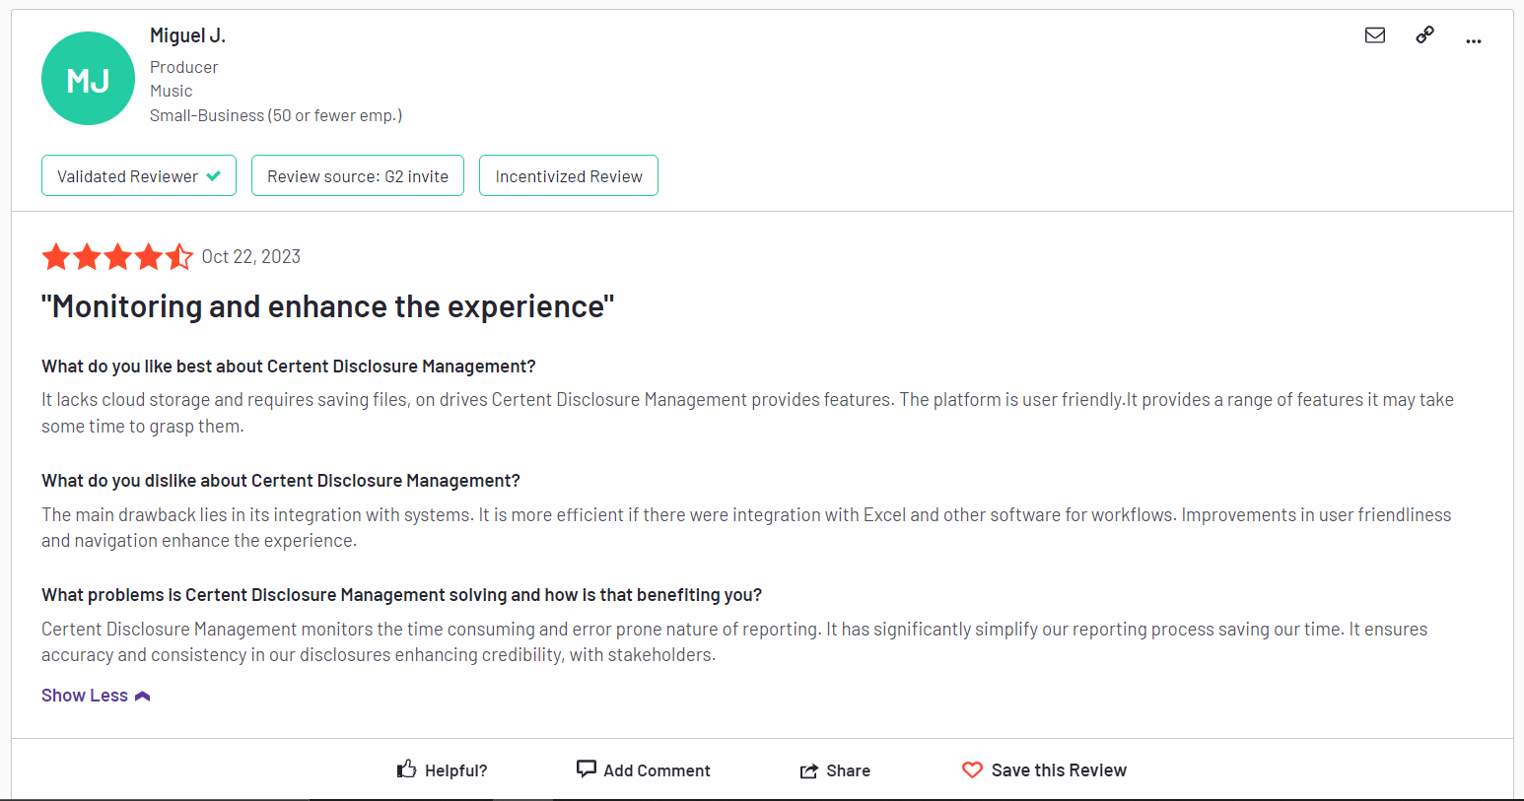 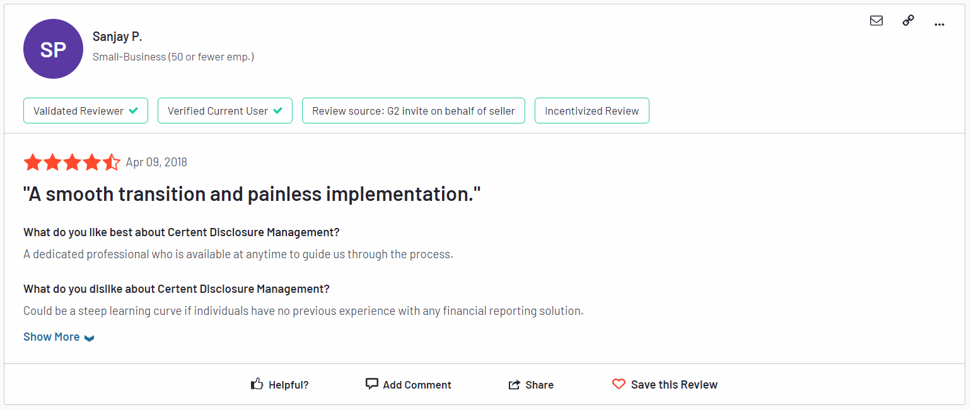 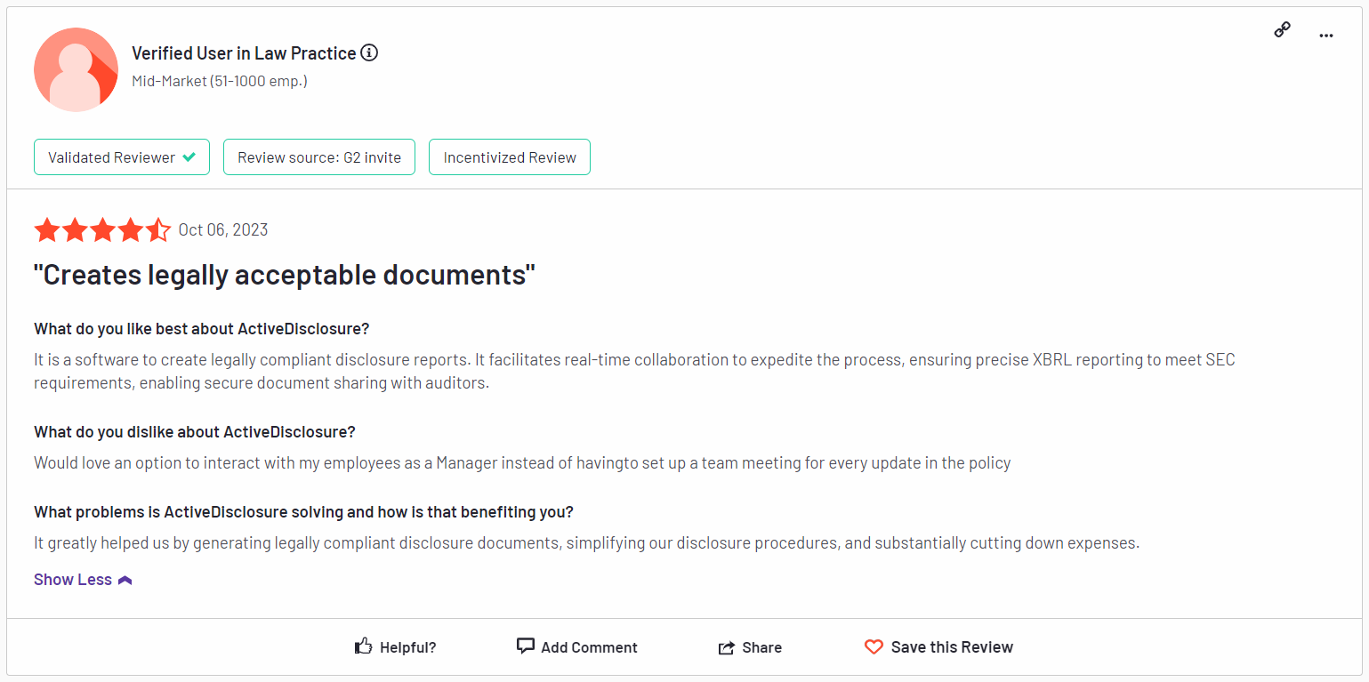

Now that we have an general understanding of the user’s needs, frustrations, and most importantly their pain points we can proceed to creating personas and storyboards to better understand the issues we need to solve.  
  
*Persona 1- Persona 3-*  
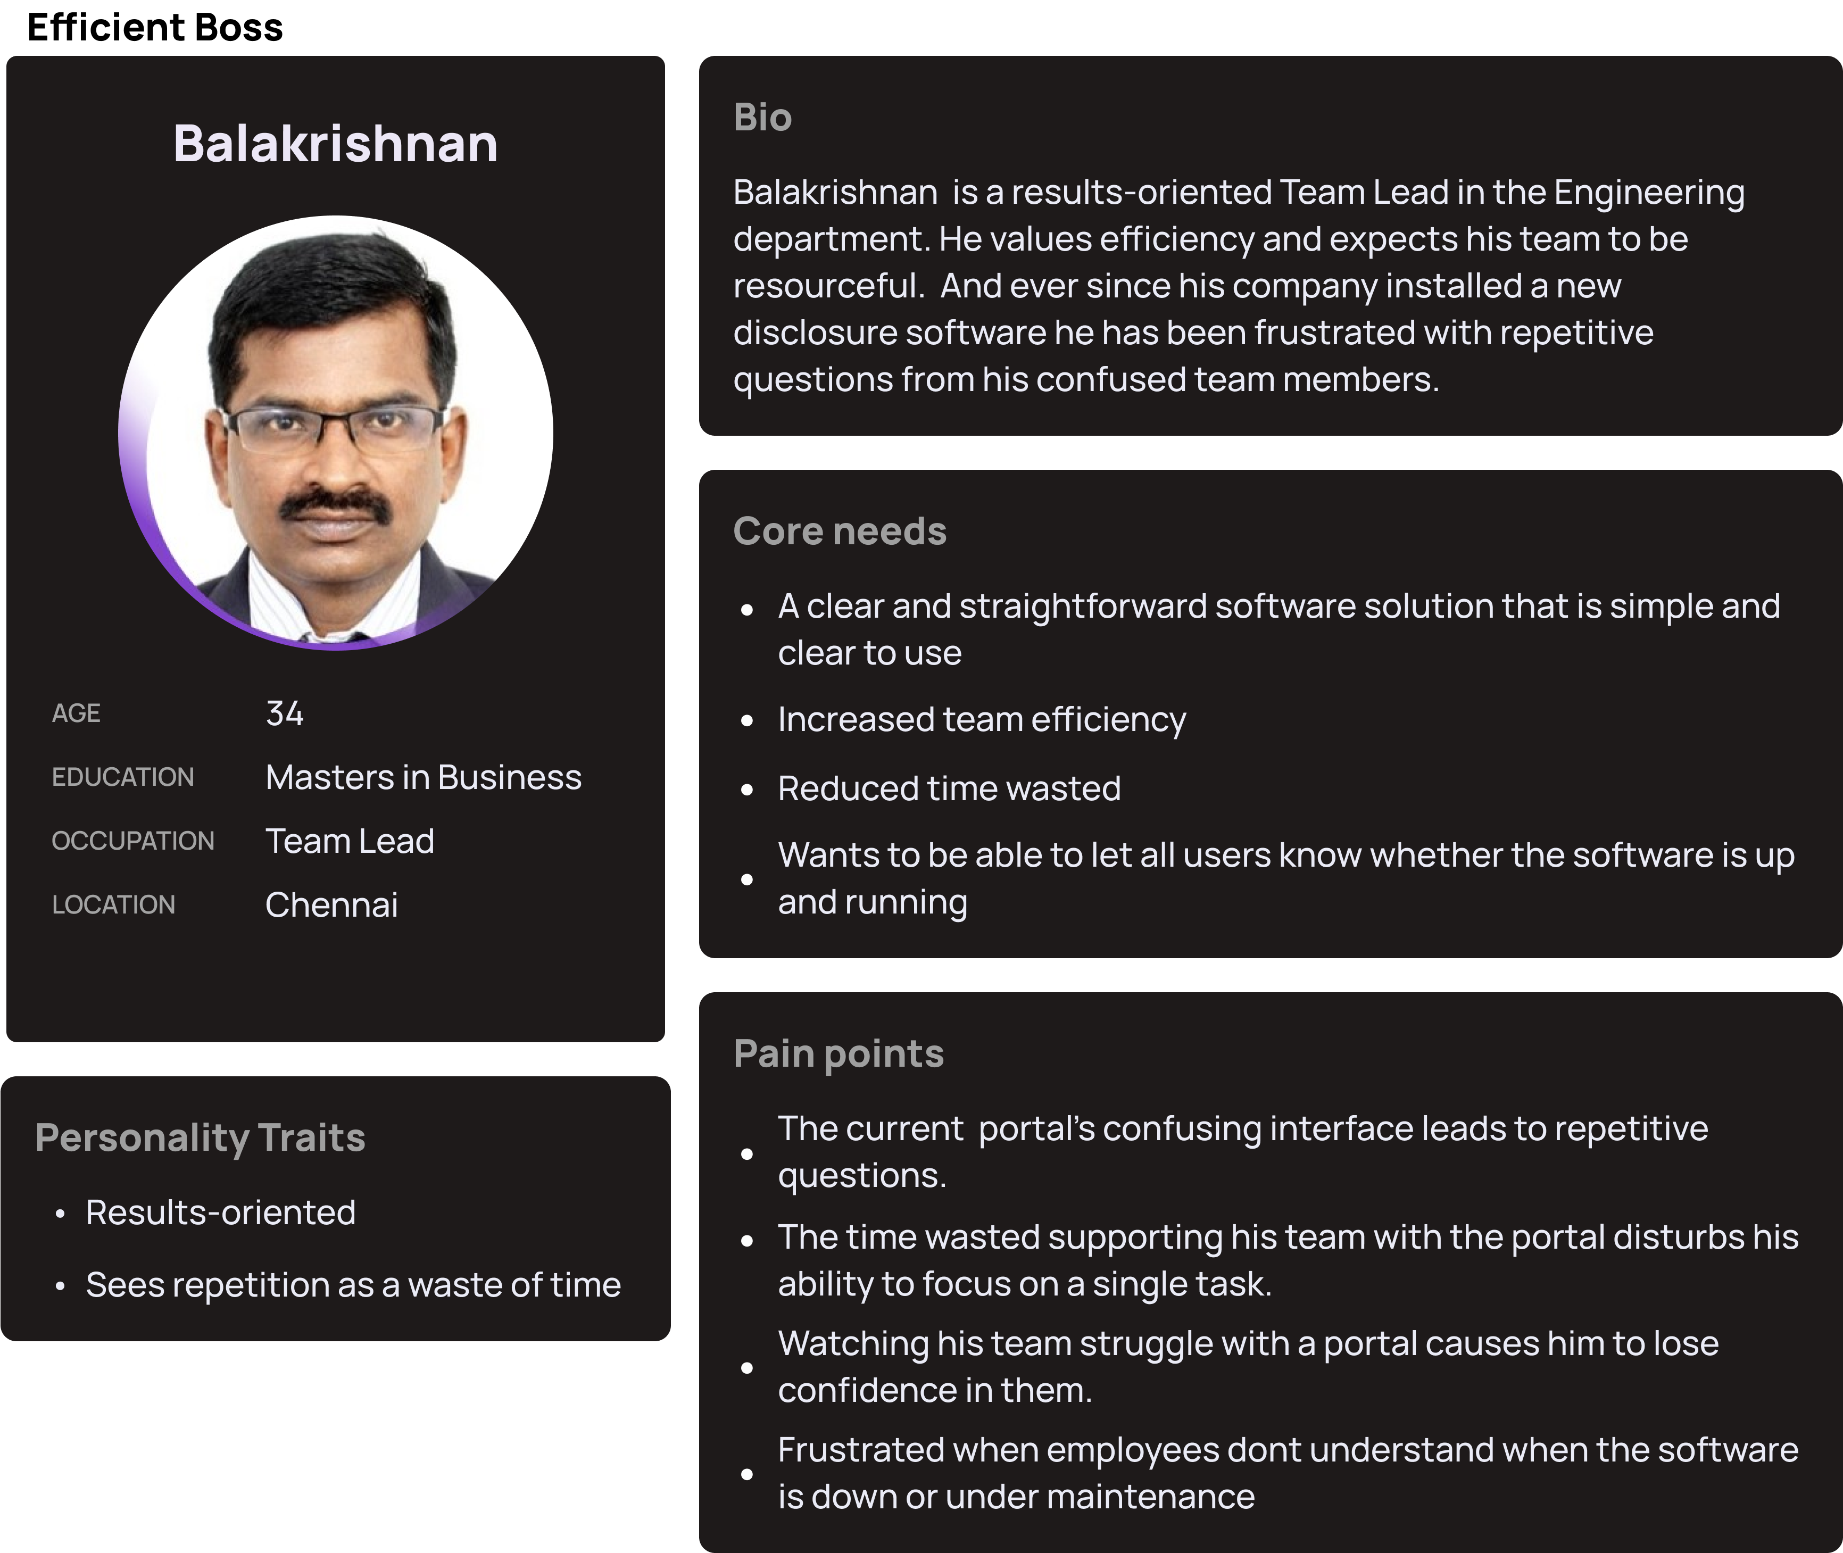 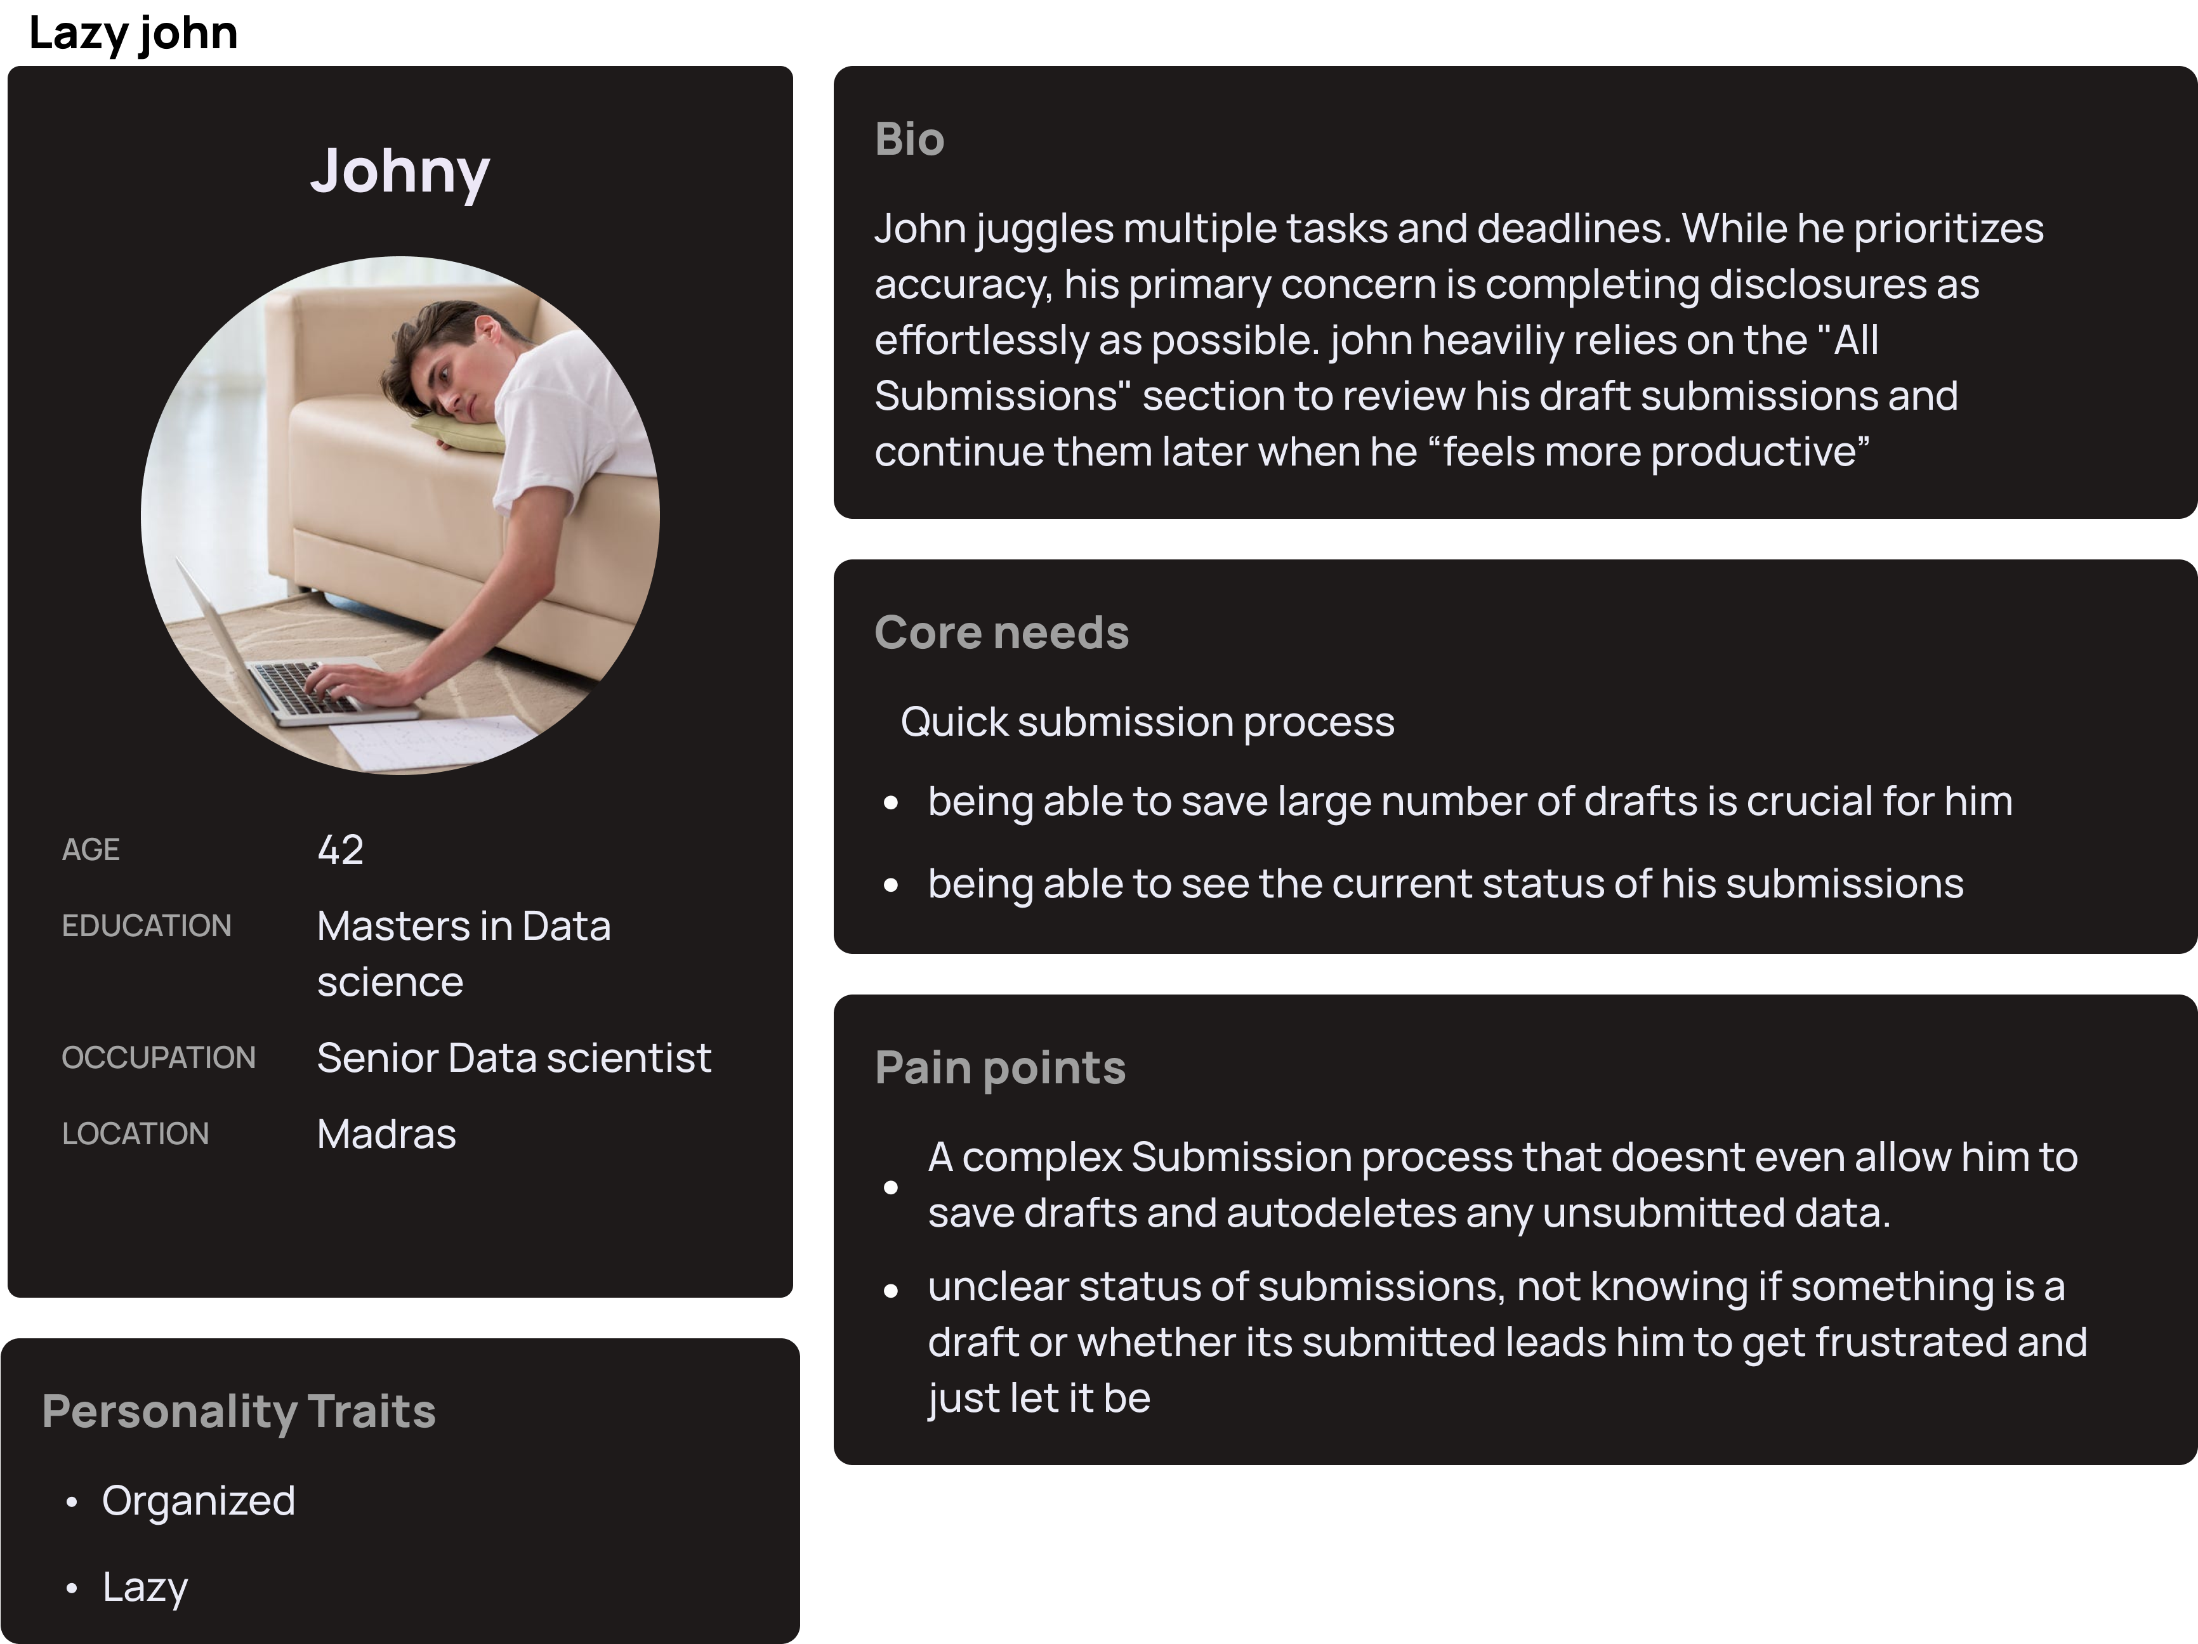

Figure 3 Figure 5

*Persona 2- Story board-*   
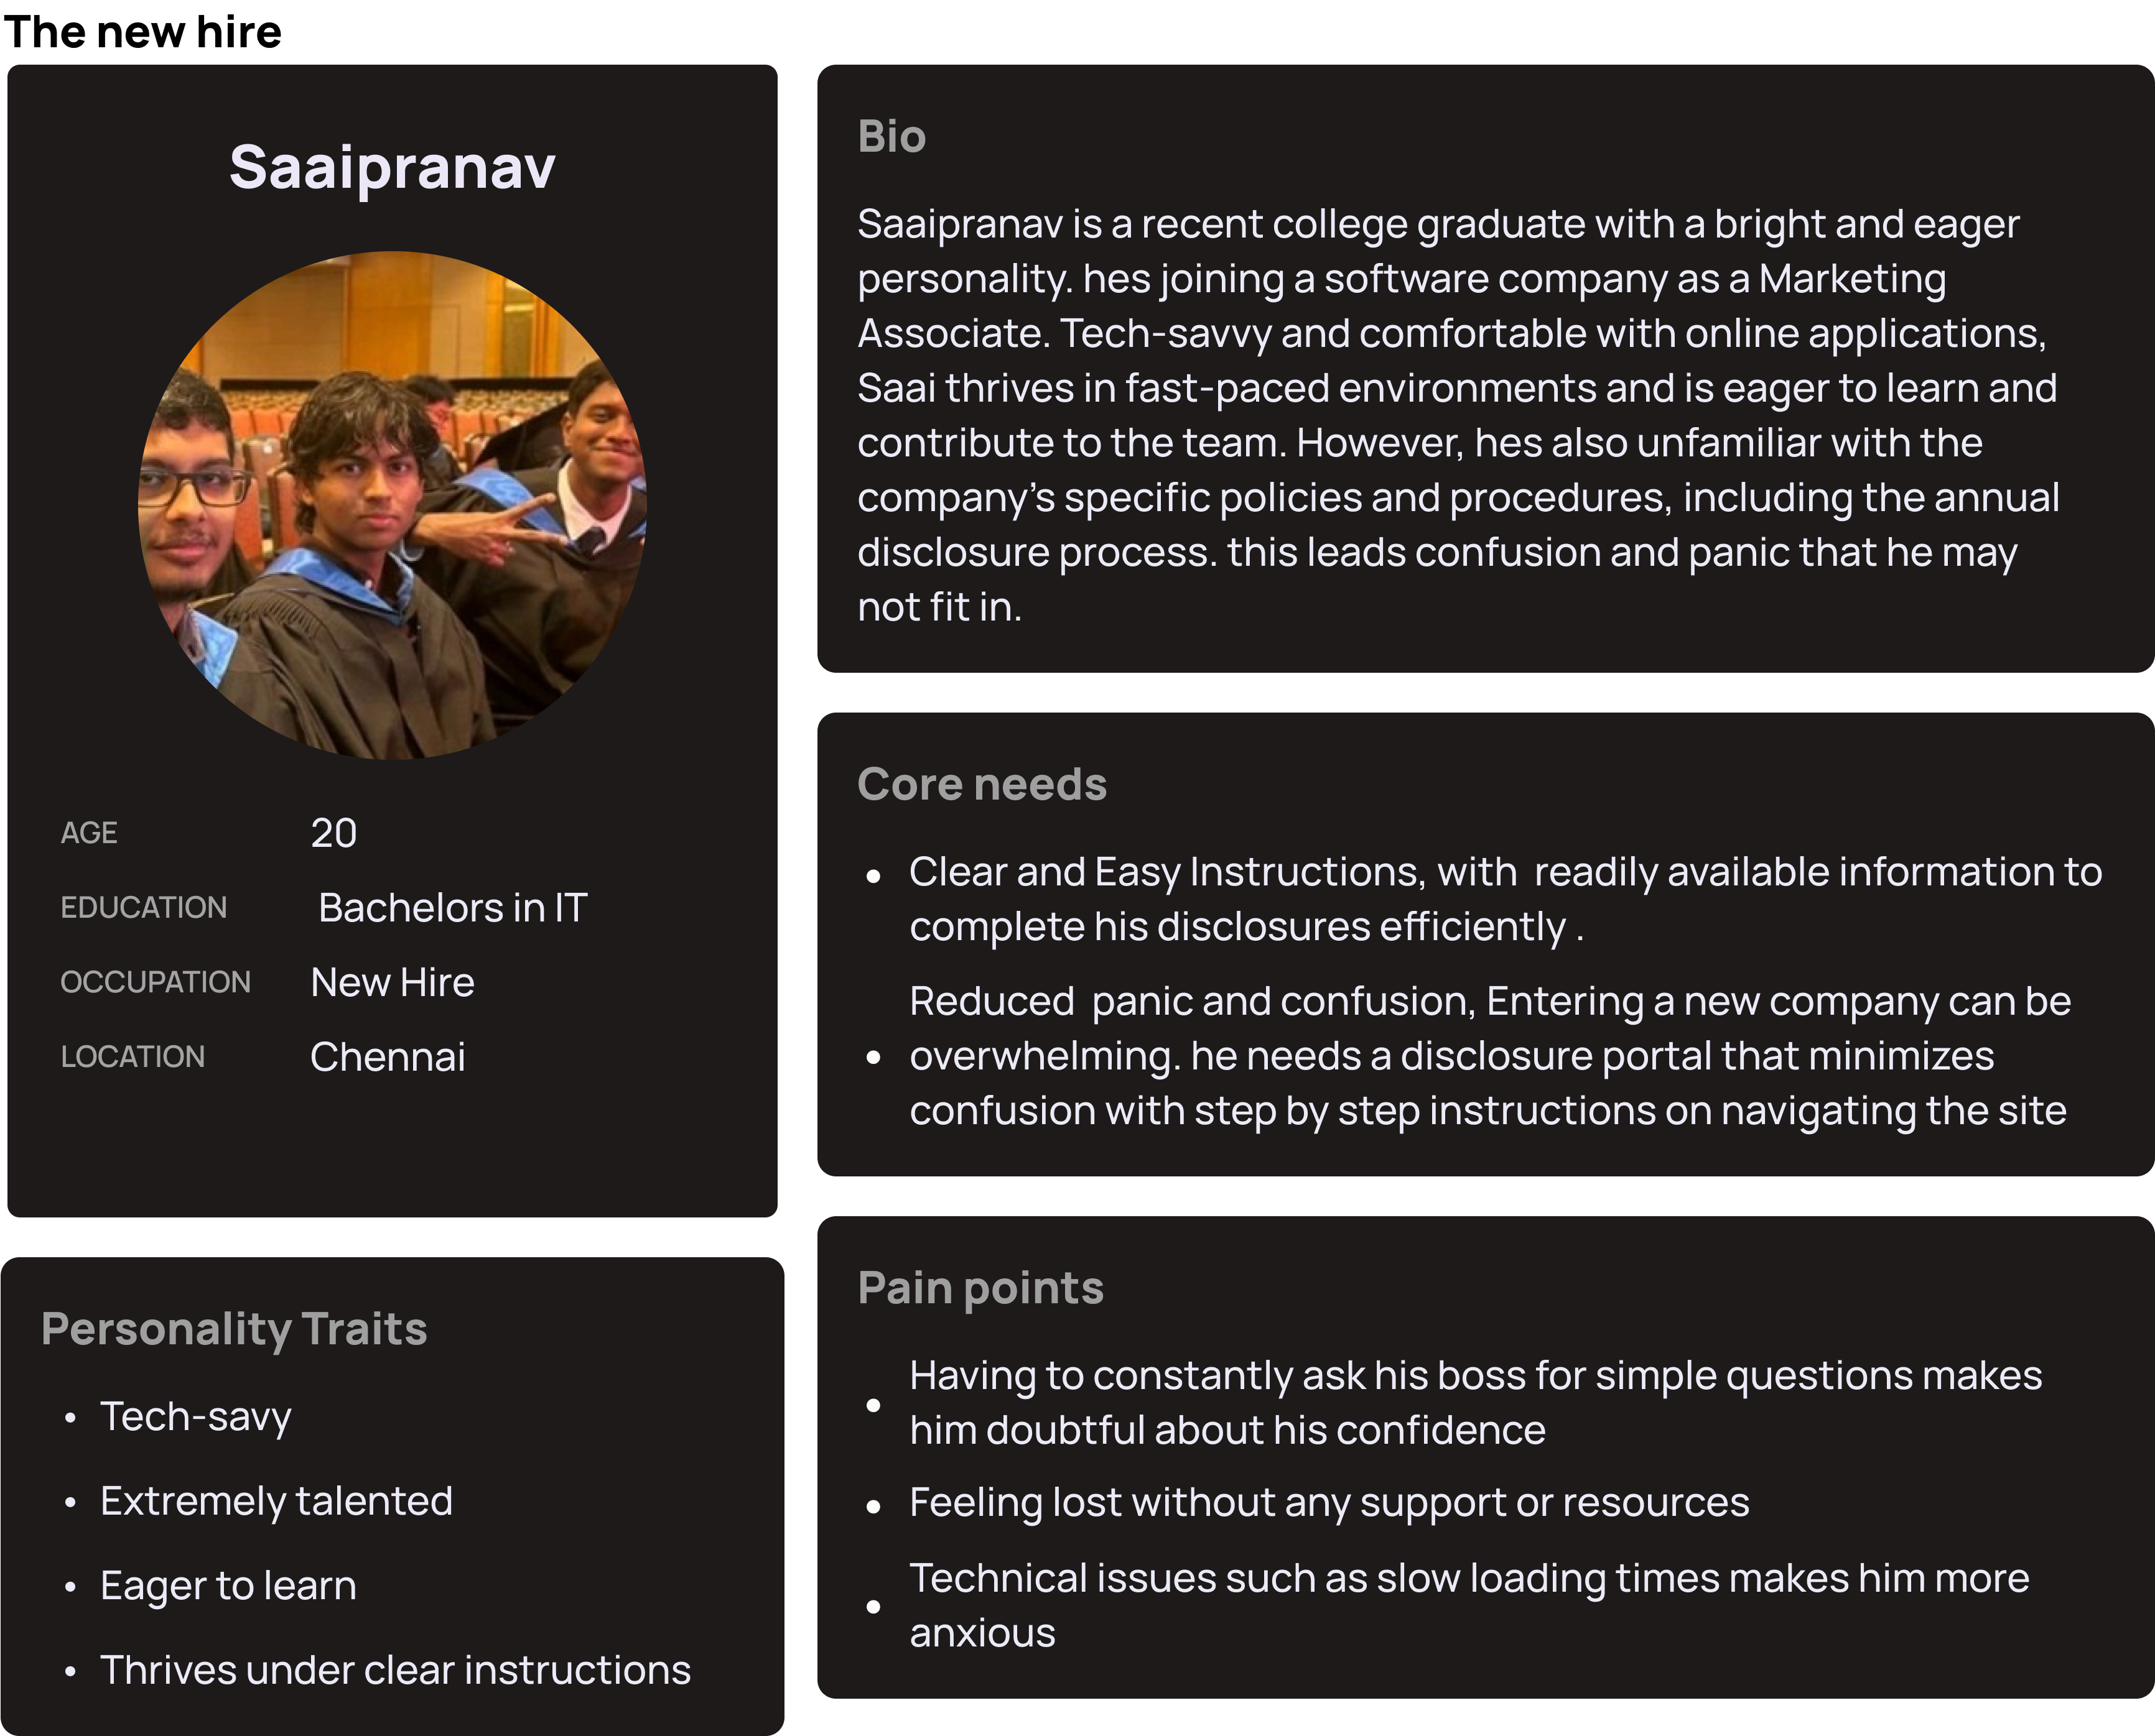 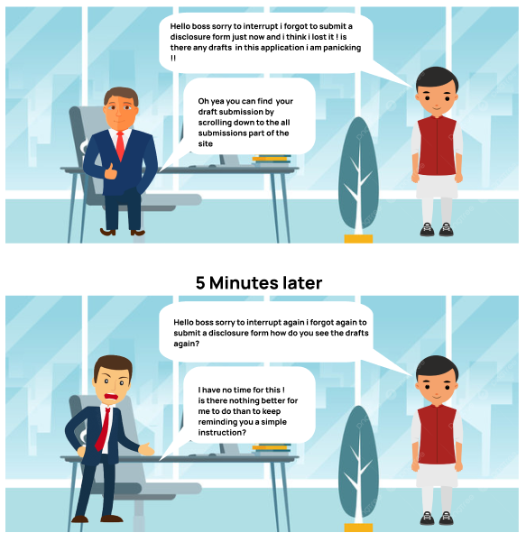

Figure 4 Figure 6

Limitations of Empathy stage-

No real- time user data, I usually conduct multiple interviews of workers who have used a disclosure software but due to time constraints and lack of interviewees available it wasn’t fiesable.

**Define-**

I think of this stageas a foundation for creating future ideations. Here I will fully state the core problem this UI is trying to solve along with its core goals.

From the research in the Previous stage (user reviews/blogs and assumptions), I identified the key pain points and needs of current disclosure softwares. Using this I can write problem statements that summarize the challenges users which proceeds to the user needs followed by the final UI goals.

Key Problems:

* The current disclosure softwares are difficult to navigate due to the lack of clear instructions, leading to user frustrations.
* Prior knowledge required to use more advanced features especially with the lack of online resources and available tutorials.
* Important updates, clarifications, or reminders regarding the disclosure process are not readily communicated to all users, leading to confusion.
* When viewing all submissions it feels too cluttered and overwhelming.

User Needs:

* Clear and straightforward instructions for every process built into the web application.
* Provided contact information on internal support.
* A way to keep employees updated on the software’s downtimes or any other important matters.
* A simpler way to show all submissions.

UI Goals:

* Ease of use, most users should be able to navigate through the website and know which sections are where with no assistance or practice.
* Dedicated sections designed to provide support and tutorials on using the software.
* A status bar that updates users about the software’s downtimes or any other important statements.
* Sort submission by date with no more than 10 displayed in the screen at a time.

**Iteration 1-**

Low fidelity MVP:

[Link](https://www.figma.com/file/GDYCqNu3x21Zqv8suEWIm4/Low-fid-convergepoint?type=design&node-id=0-1&mode=design&t=t9tNKdjR865yib6s-0)  
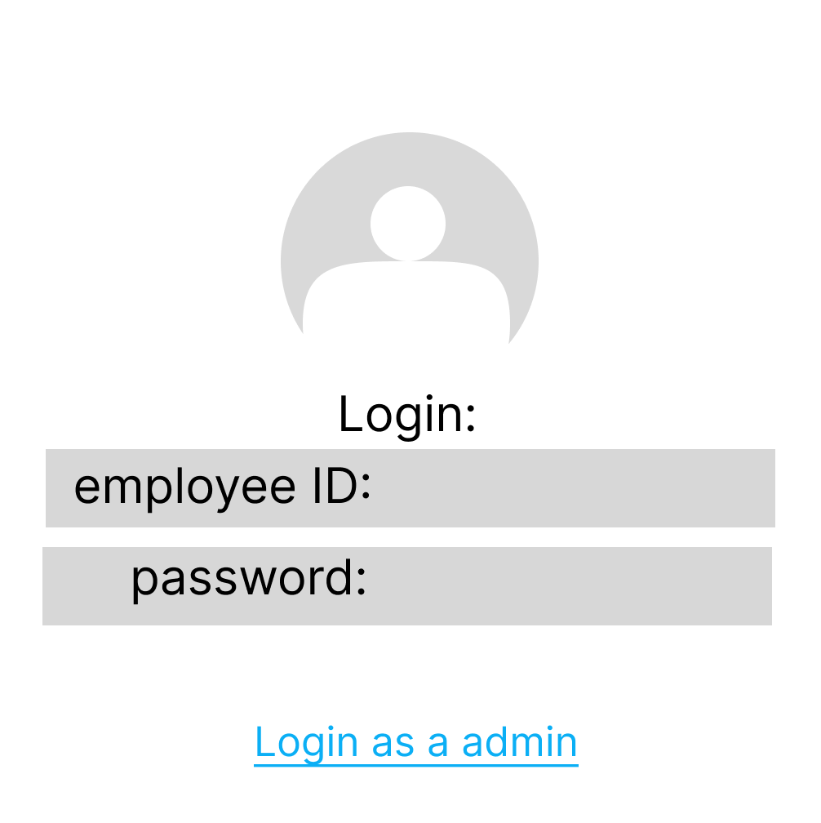 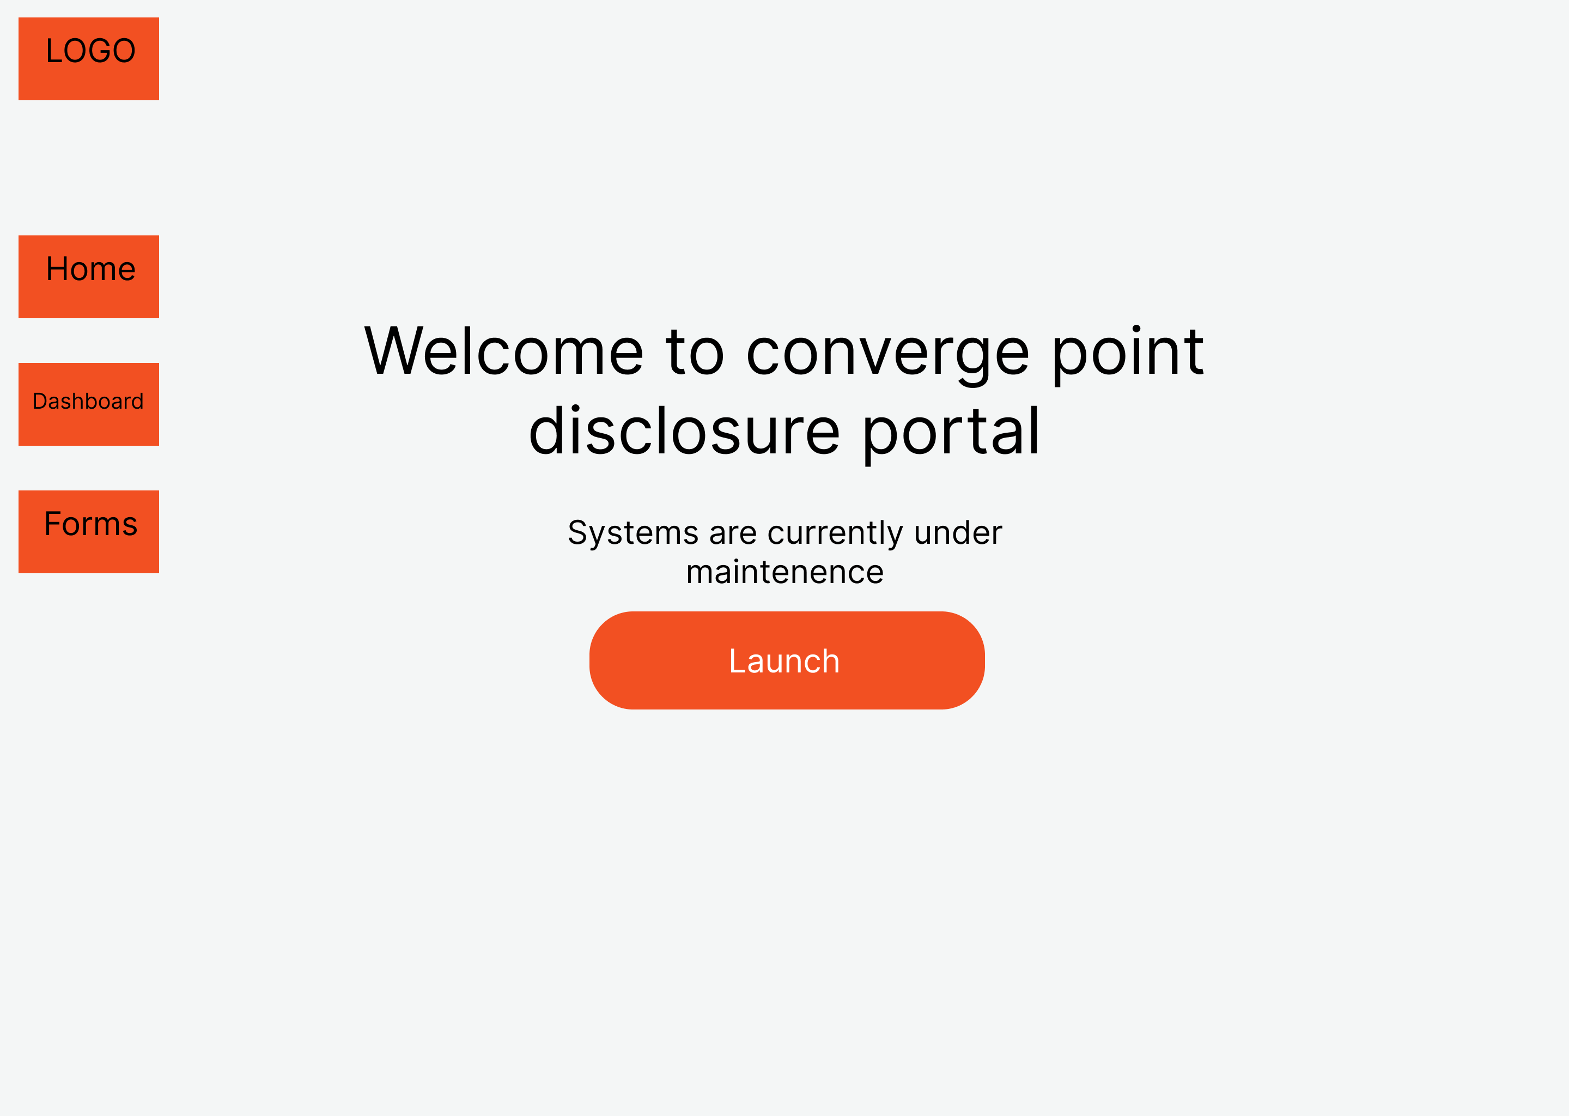 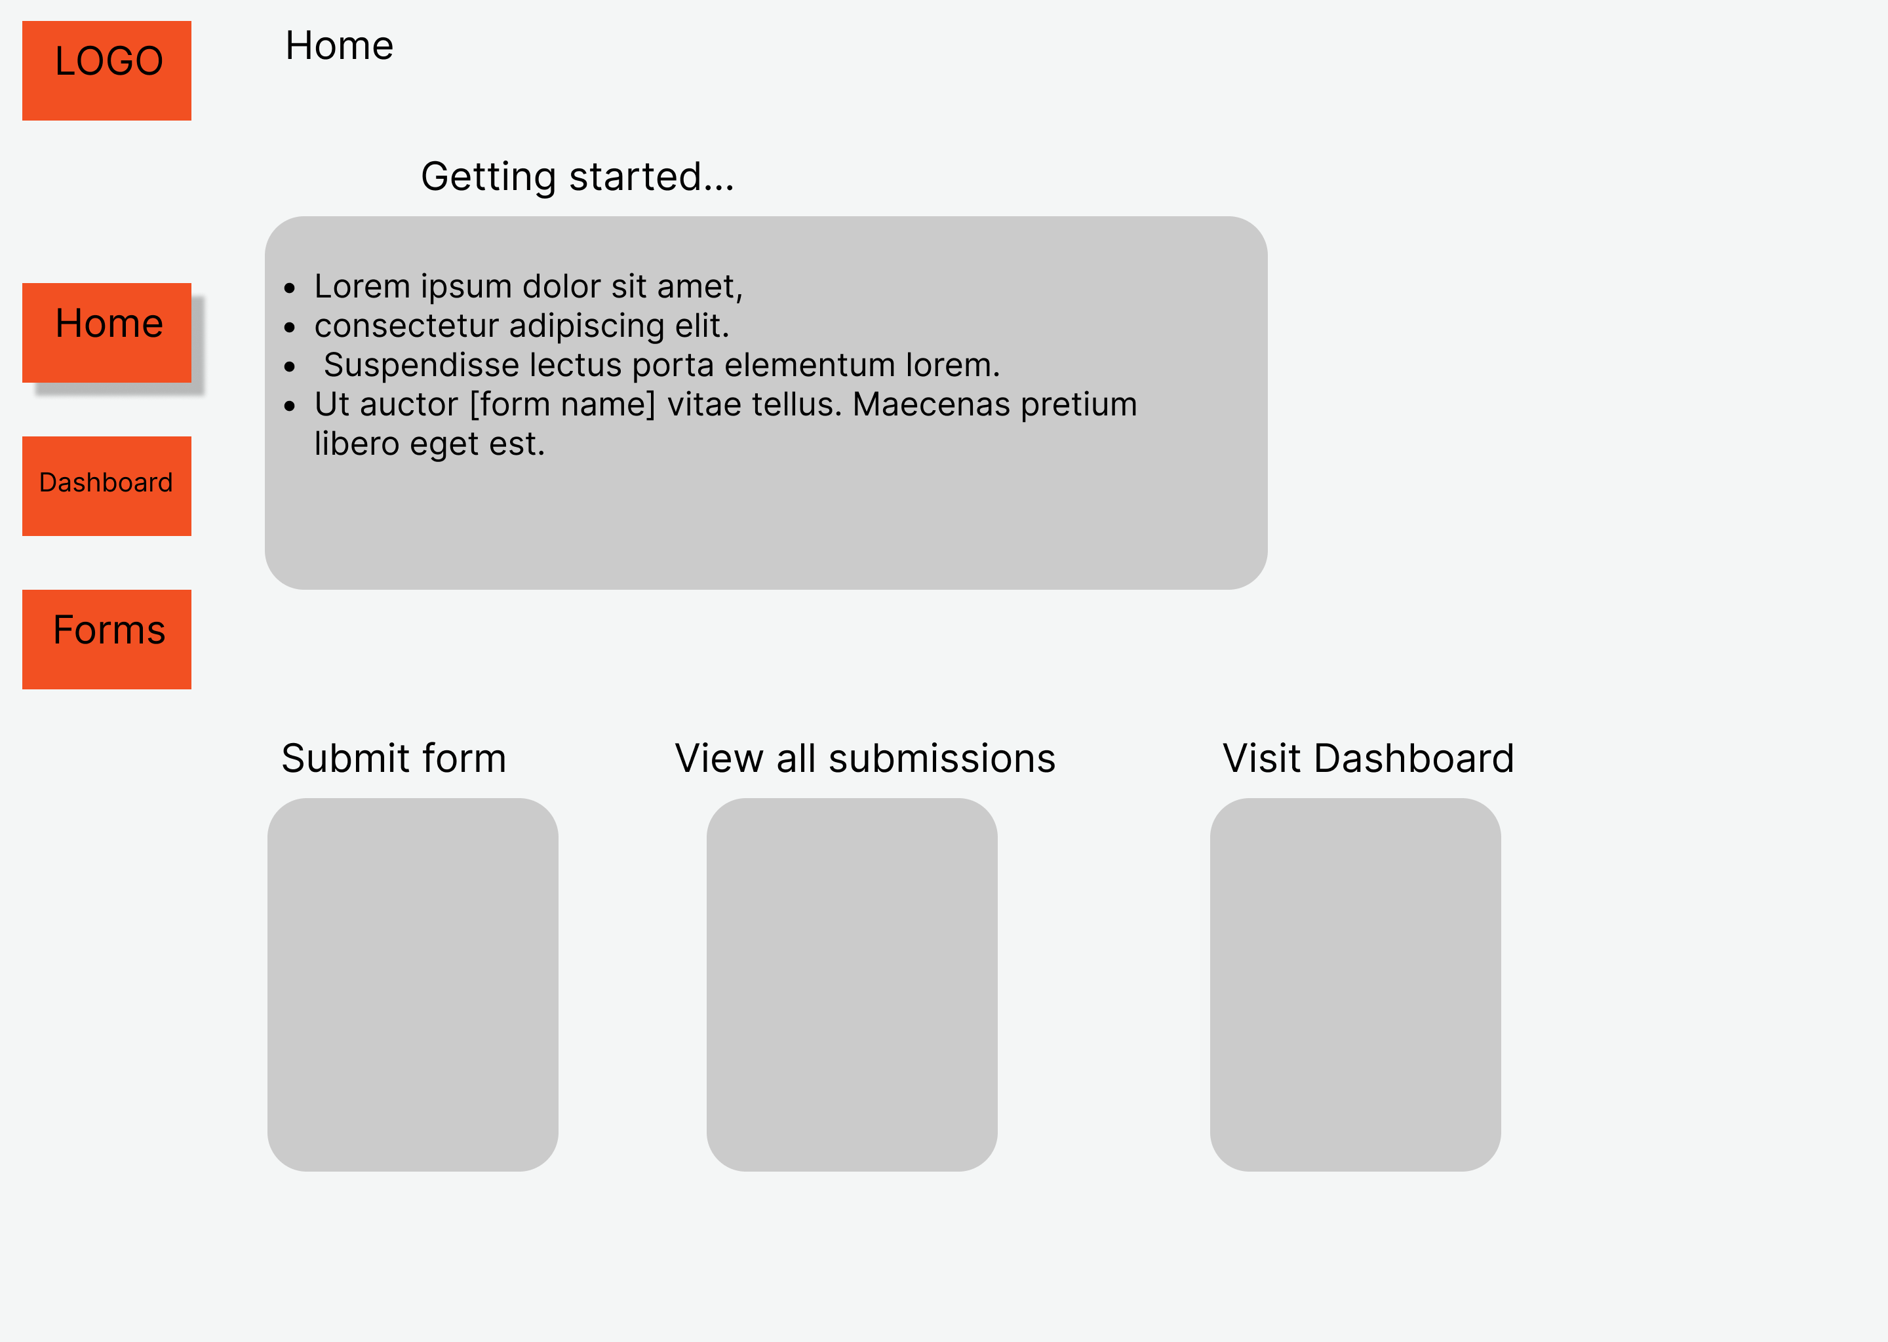 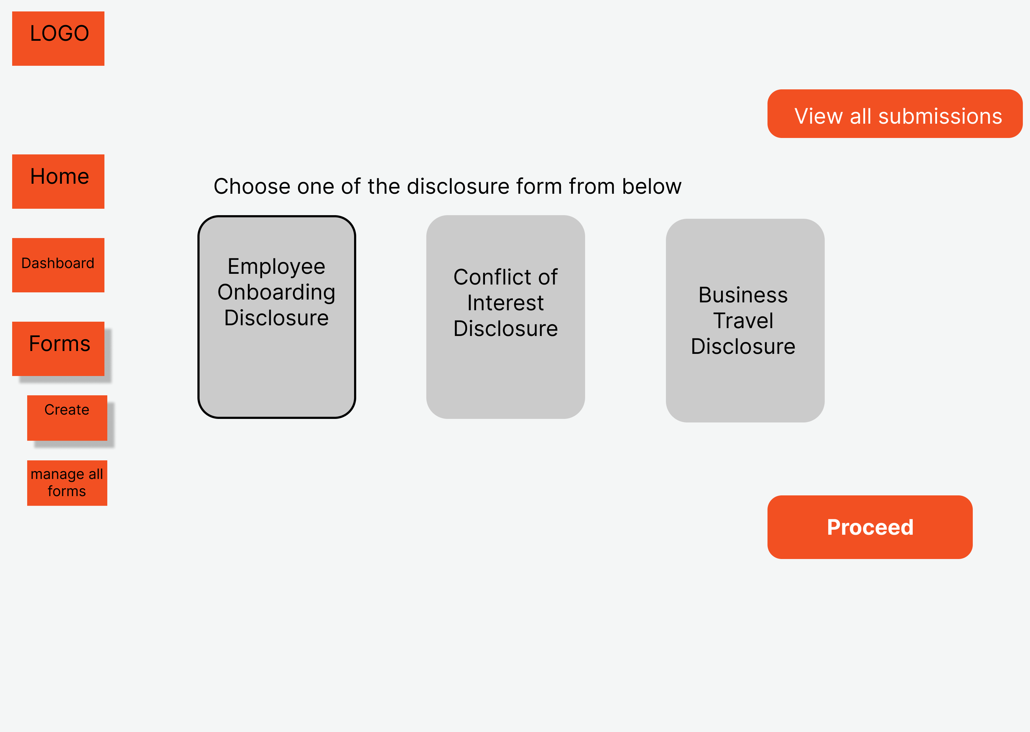 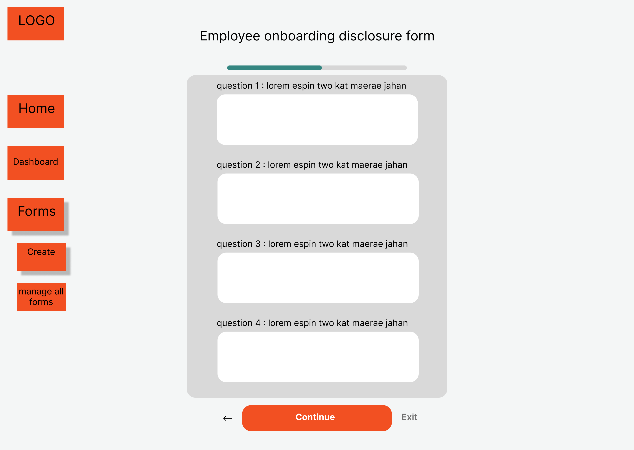 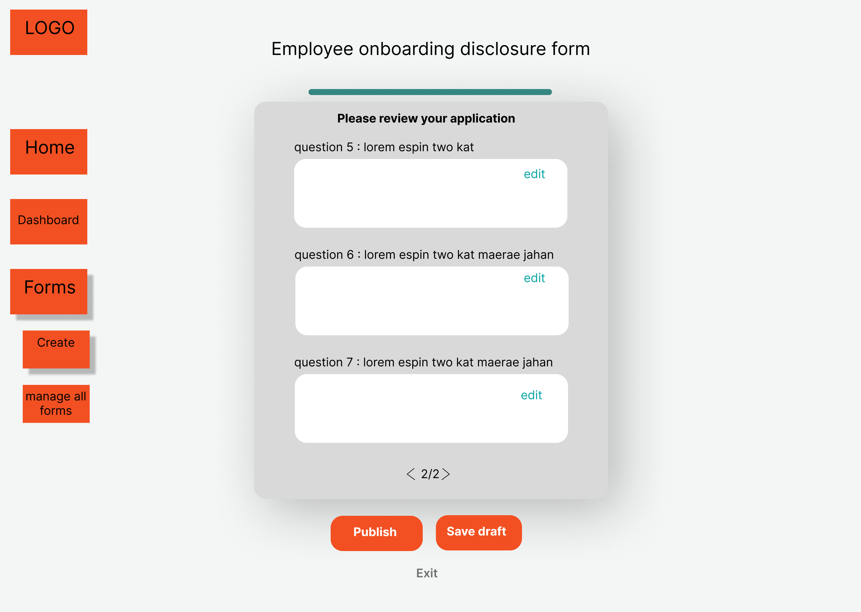 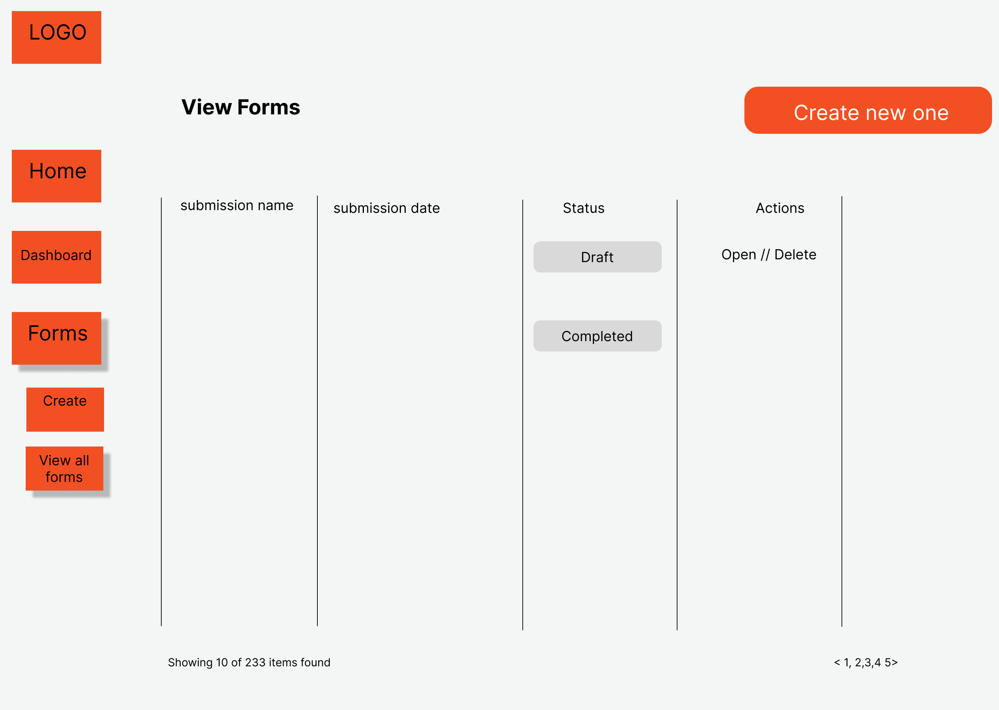 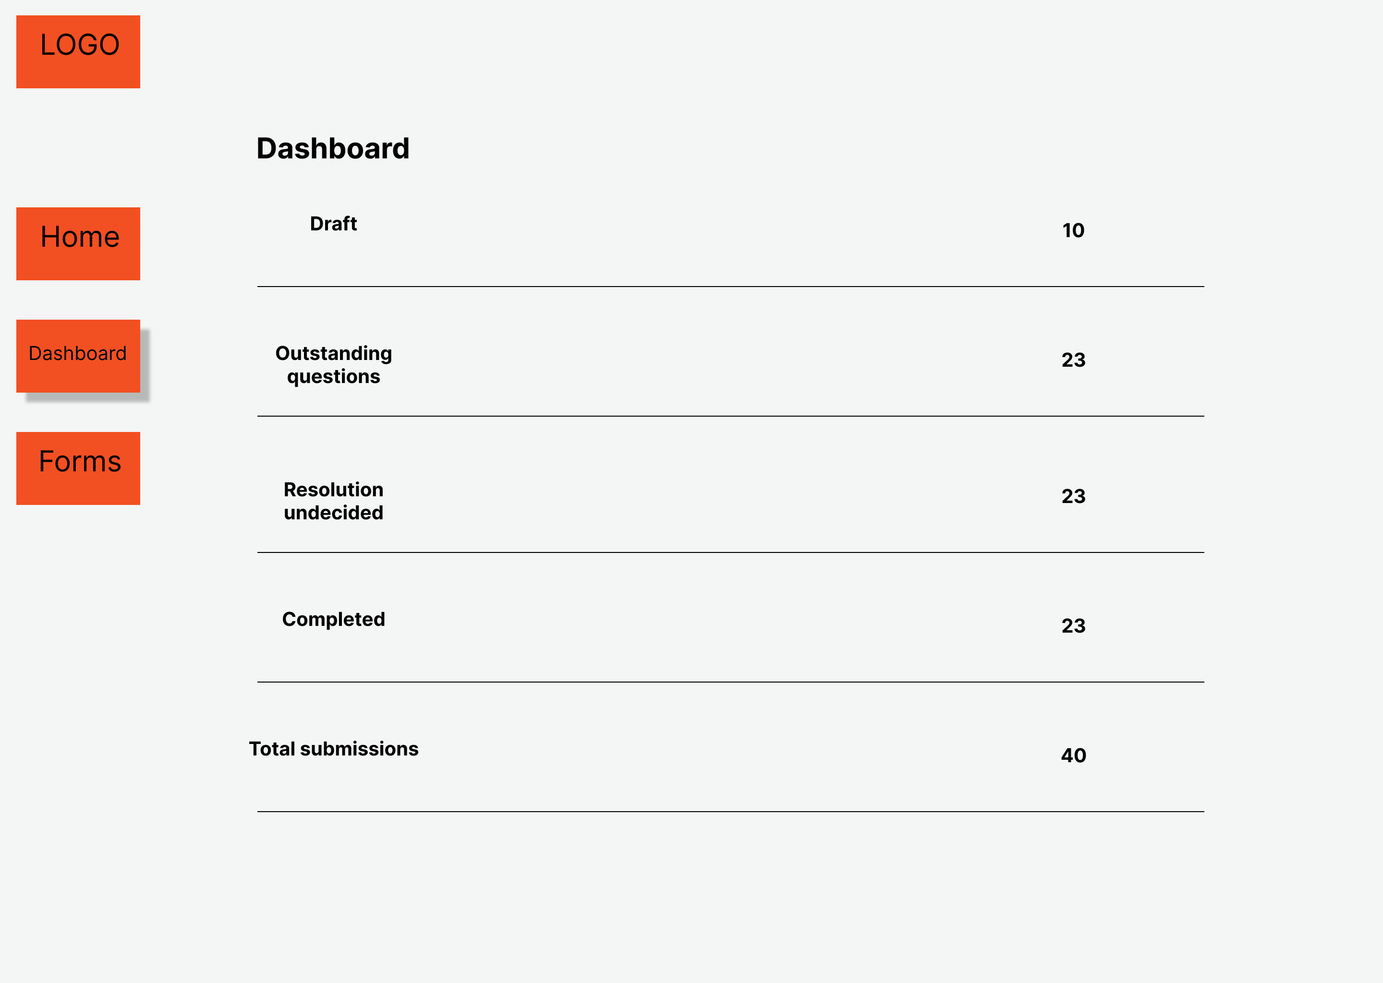

User testing:

[Interview link](https://youtu.be/z1NmLEs2iTg)

Objective: Is to understand user’s experience using the low-fidelity prototypes and identify any areas for improvement. Read the users thoughts while navigating through the site.   
  
Questions:

1. Has your company every used an online portal to submit disclosure forms or anything similar?
2. What are some important features you look for in an online disclosure portal?
3. What types of issues do you typically face in those portals?

Prototype walkthrough:

While showcasing the prototype I explain the interviewee on each of the process such as submitting a form and ask if it was clear and if there are any possible suggestions.  
  
*Feedback Grid*  
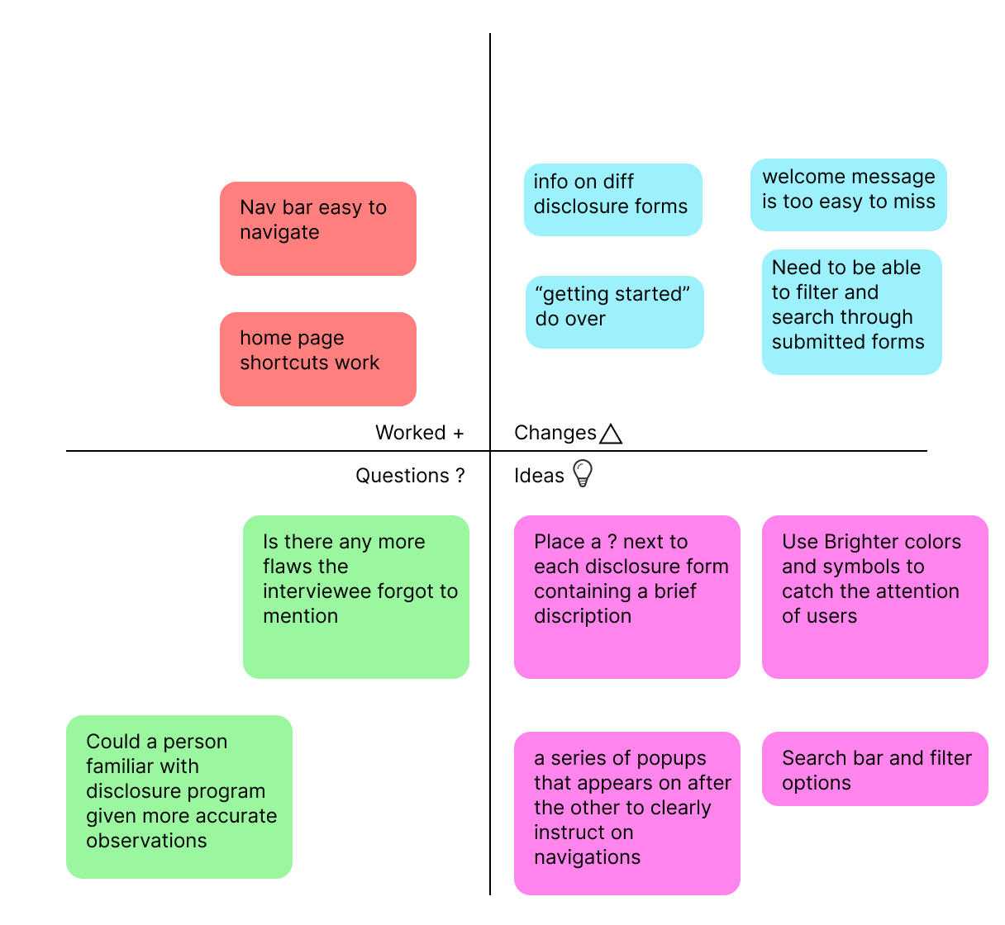

**Iteration 2-**

Mid fidelity MVP:

[Link](https://www.figma.com/file/GDYCqNu3x21Zqv8suEWIm4/Low-fid-convergepoint?type=design&node-id=0-1&mode=design&t=t9tNKdjR865yib6s-0)  
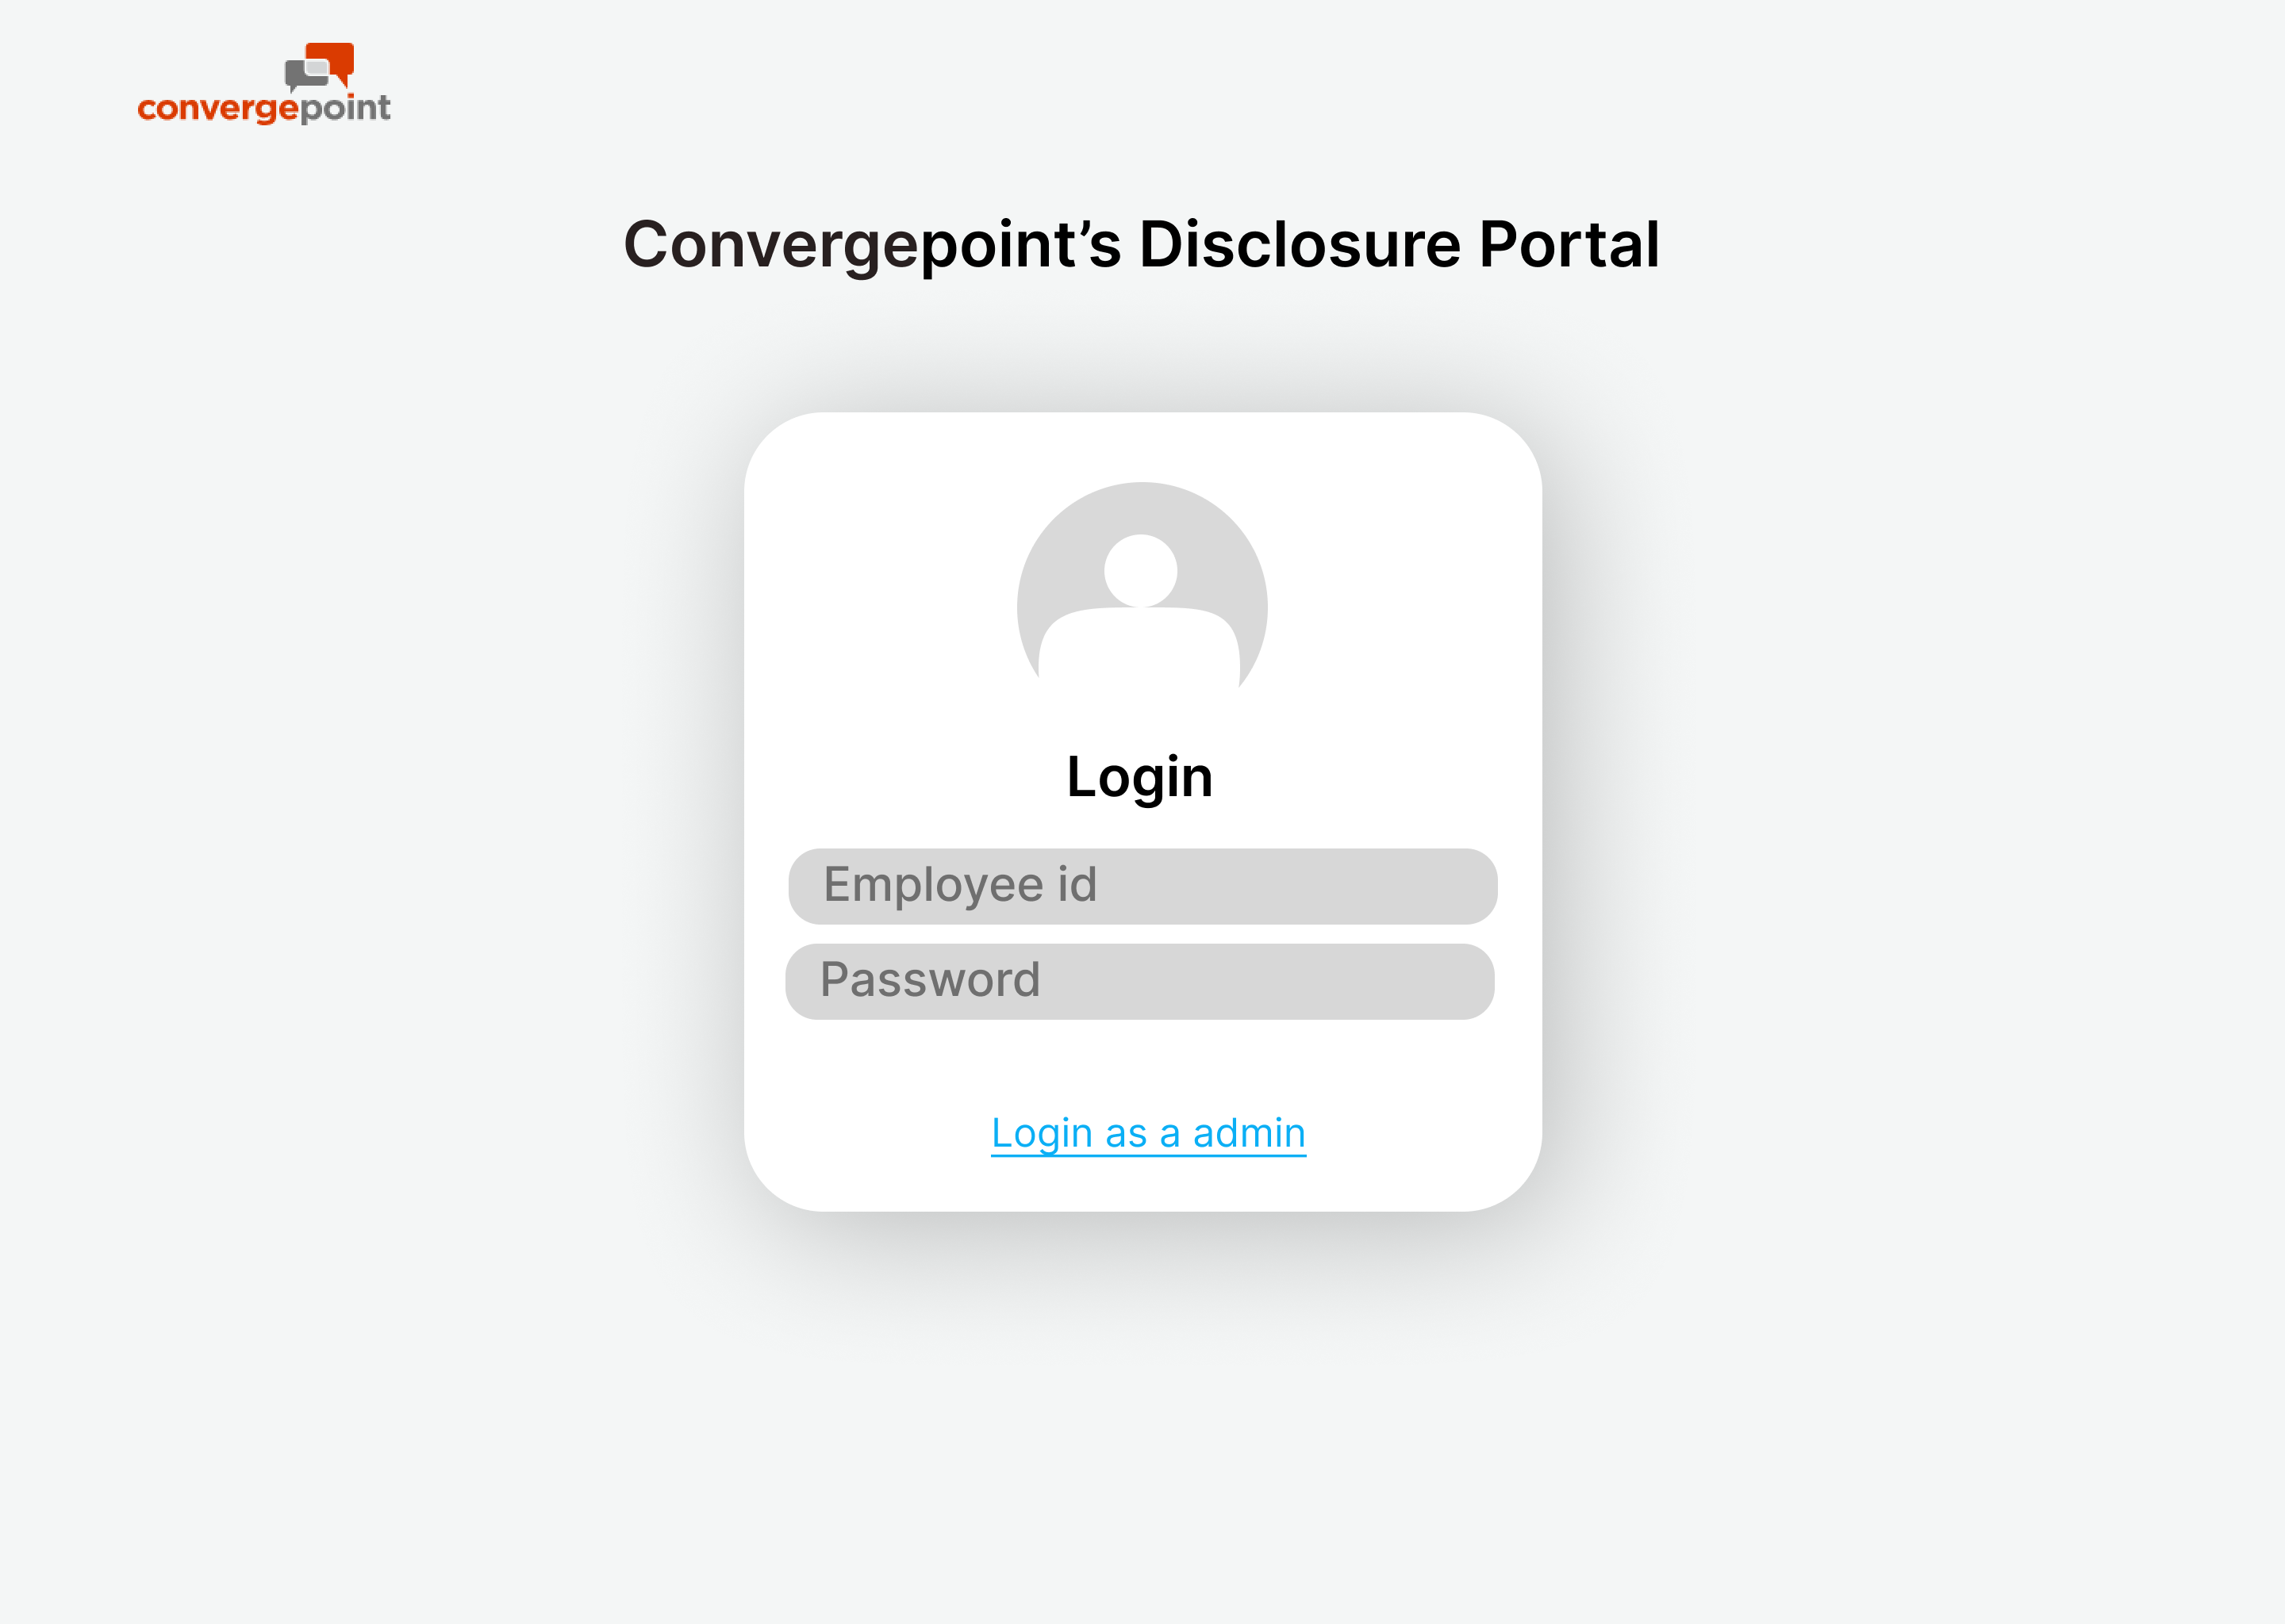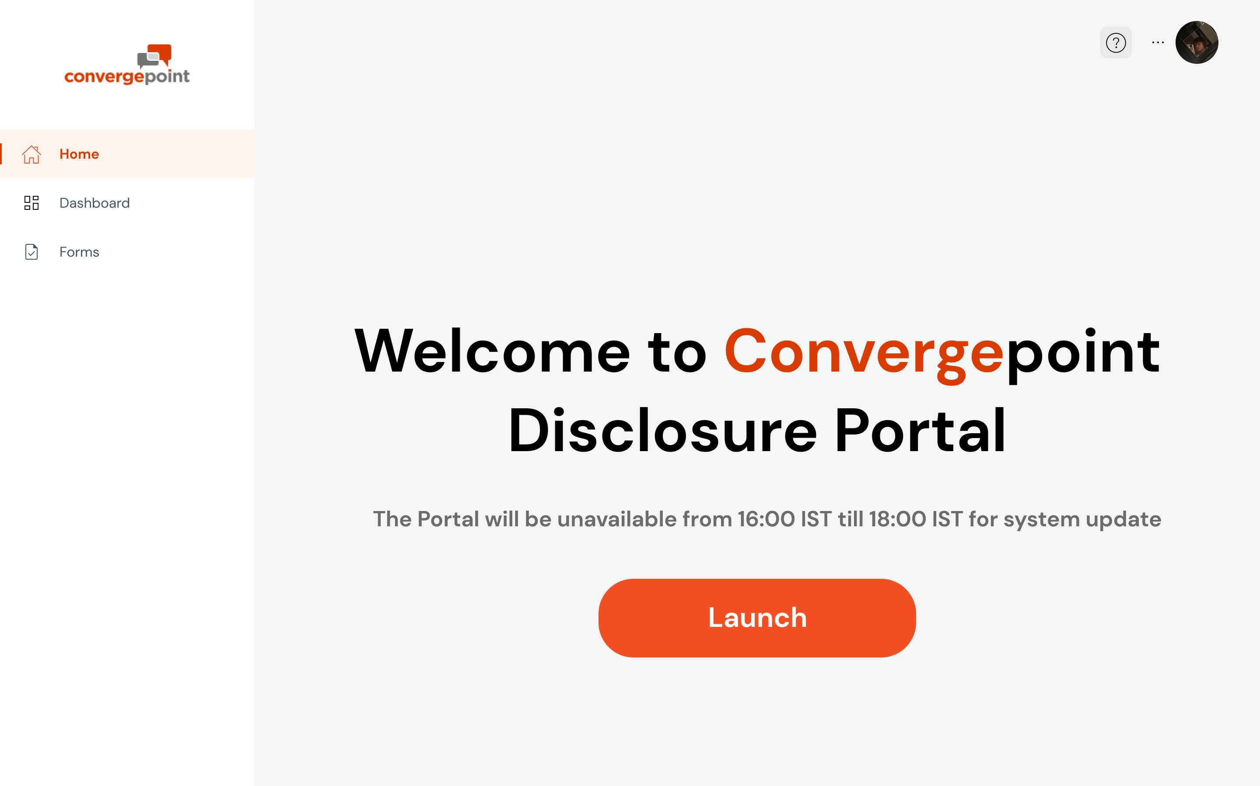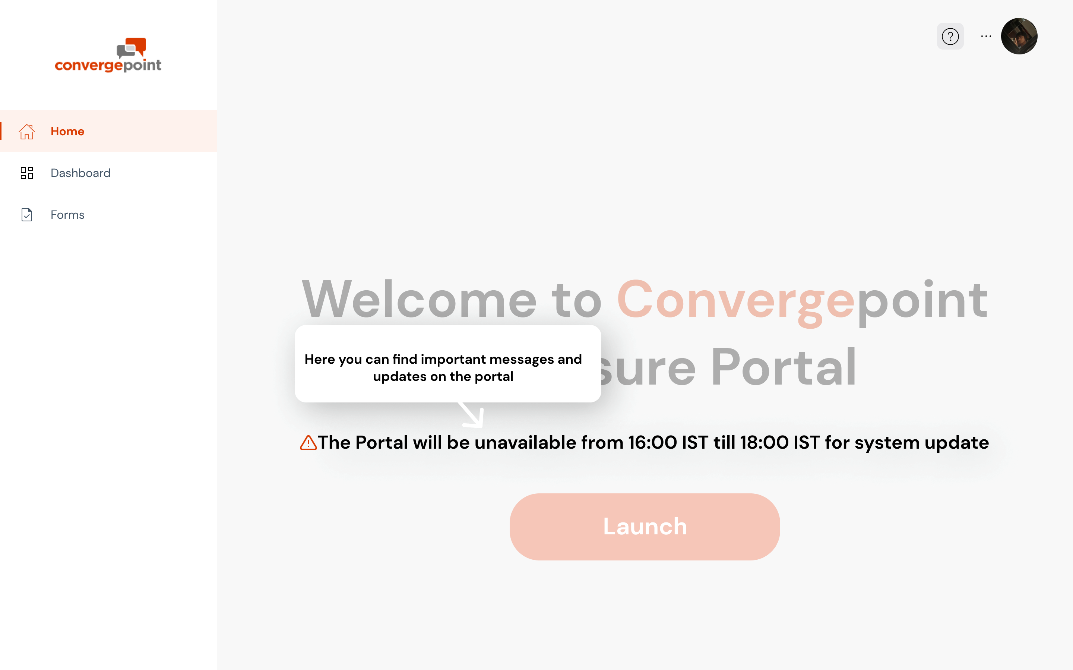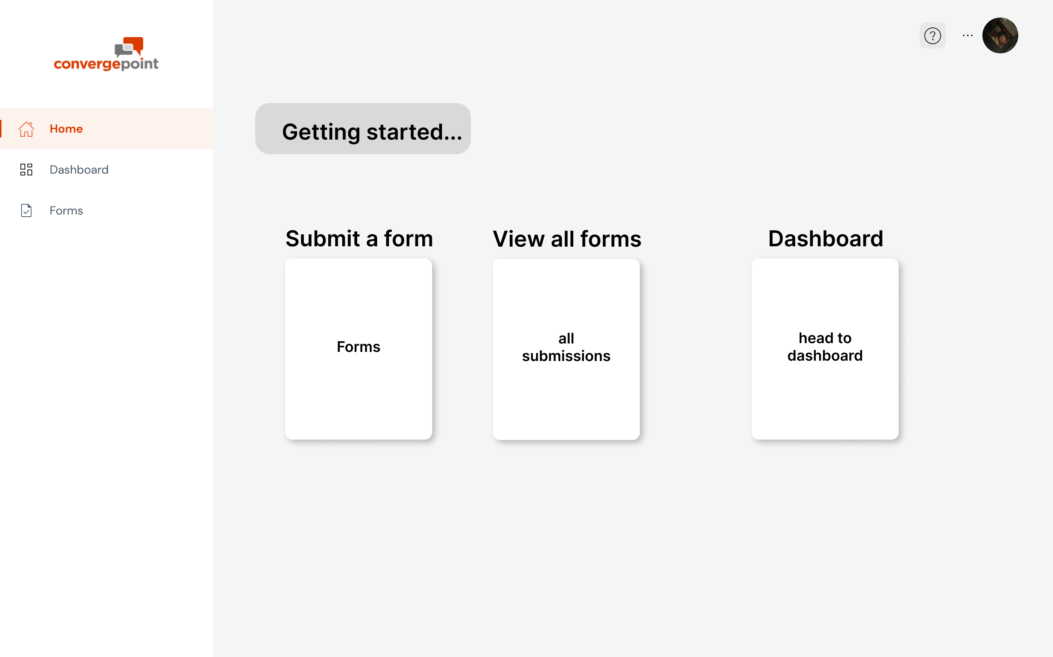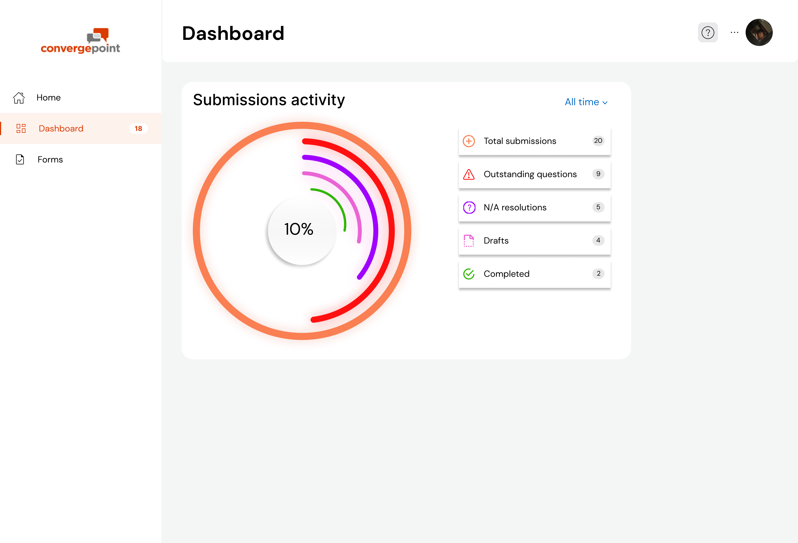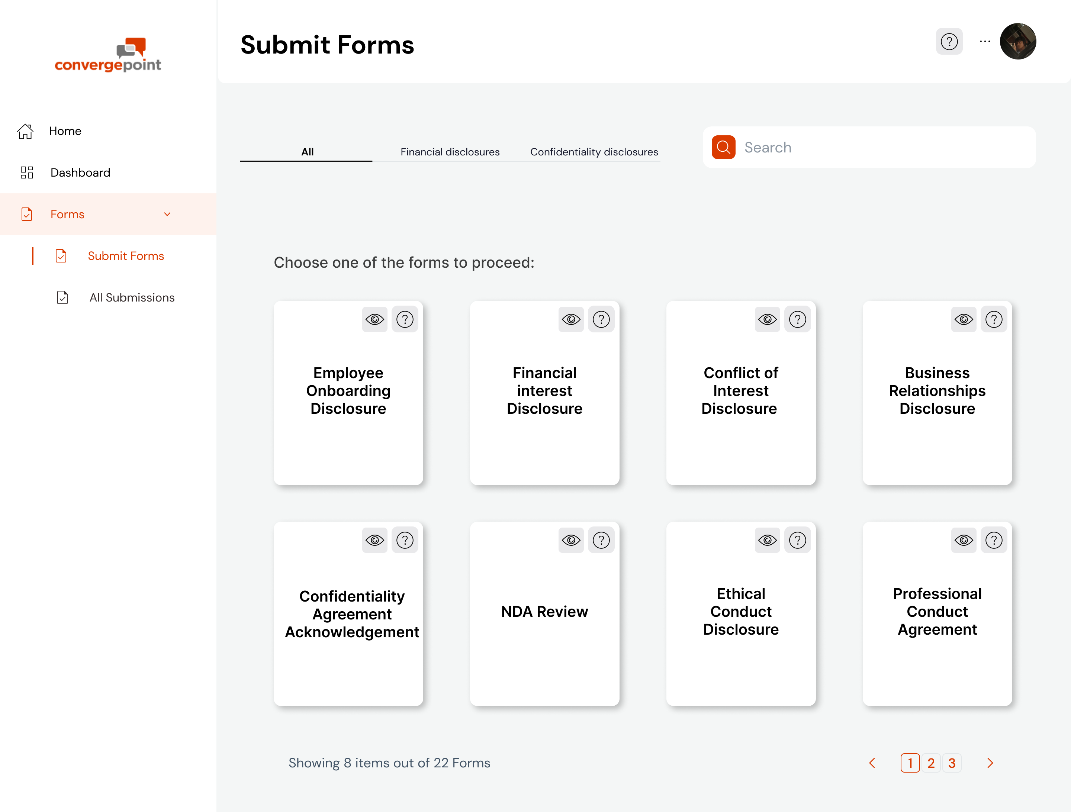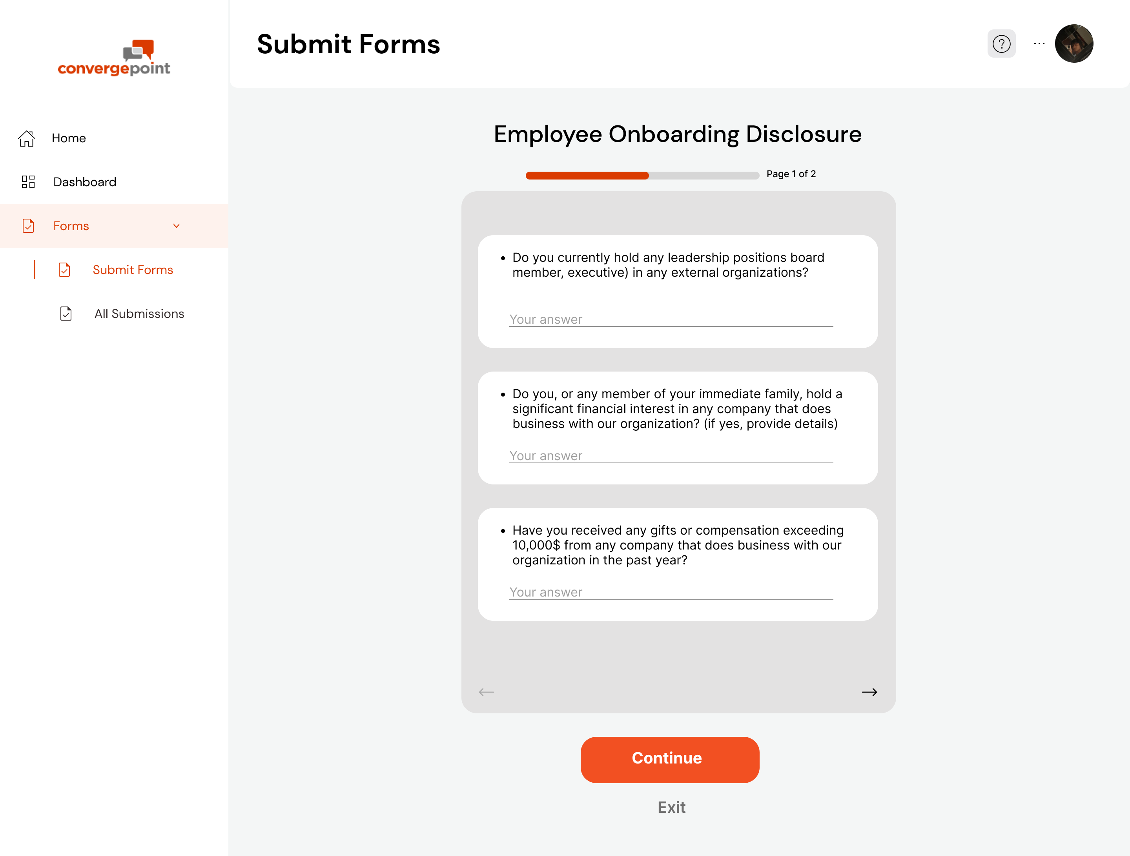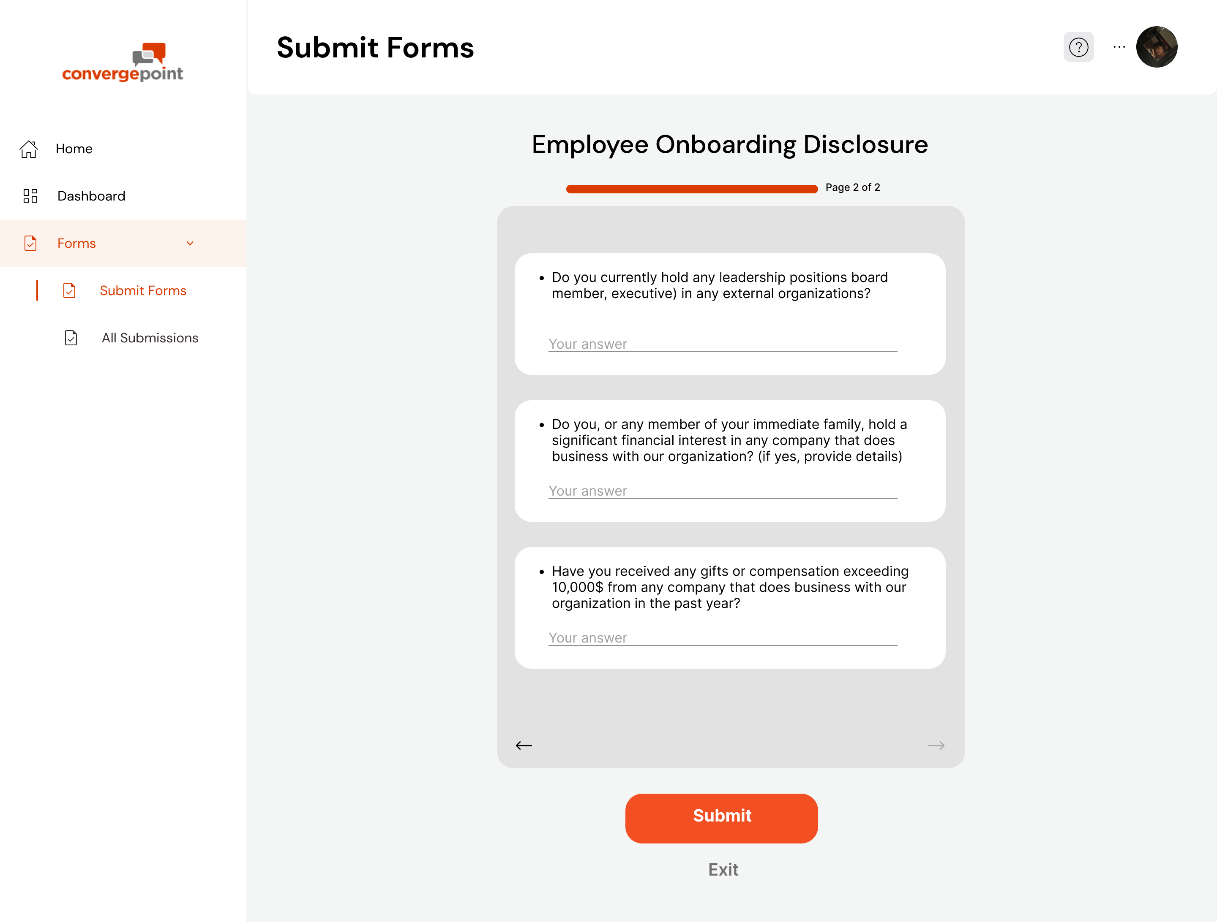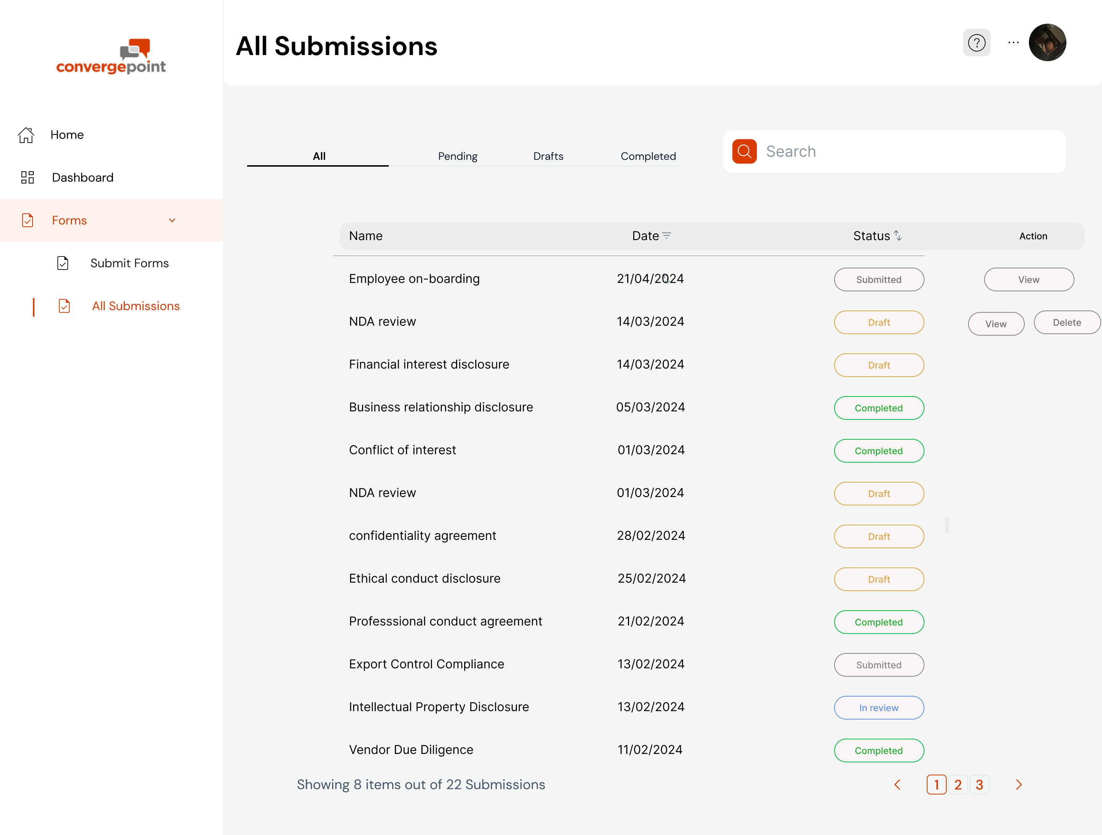

Guerrilla Usability Testing :

First I briefly explain the purpose of the test: to understand how users interact with a hypothetical disclosure portal interface.

Then I display the mid fi and ask the interviewee to think aloud as they navigate the mockup, verbalizing their thoughts and any challenges they encounter all while having their camera on to focus on their expressions

The Test:

Explain in detail the purpose of a disclosure software then ask them to imagine they are logging in to the disclosure portal for the first time.

I did not provide them with any instructions and asked them to complete tasks such as can “tell me where to create new form” “where do you see the form you just created”

Comments made during the test by interviewee:

"the home page seems to be just the nav bar repeated”

“View all forms slightly overwhelms me”  
 “when I have a lot of things that need my attention in dashboard I think a reminder in homepage would be nice”

"the layout is really easy to understand”  
 “yea the hierarchy of information is appropriate “  
  
I also ran some possible and current features and asked them to rate it 1-10:  
 1. an appropriate symbol to accompany the admin message in the homepage: 10

2. Skippable popup tutorial: 8  
 3. Utilising the dashboard whitespace for possible shortcuts: 10  
 4. Visual representation of Dashboard data: 10  
 5. Adding pictures to Choose forms Grid: 2

*Feedback grid*

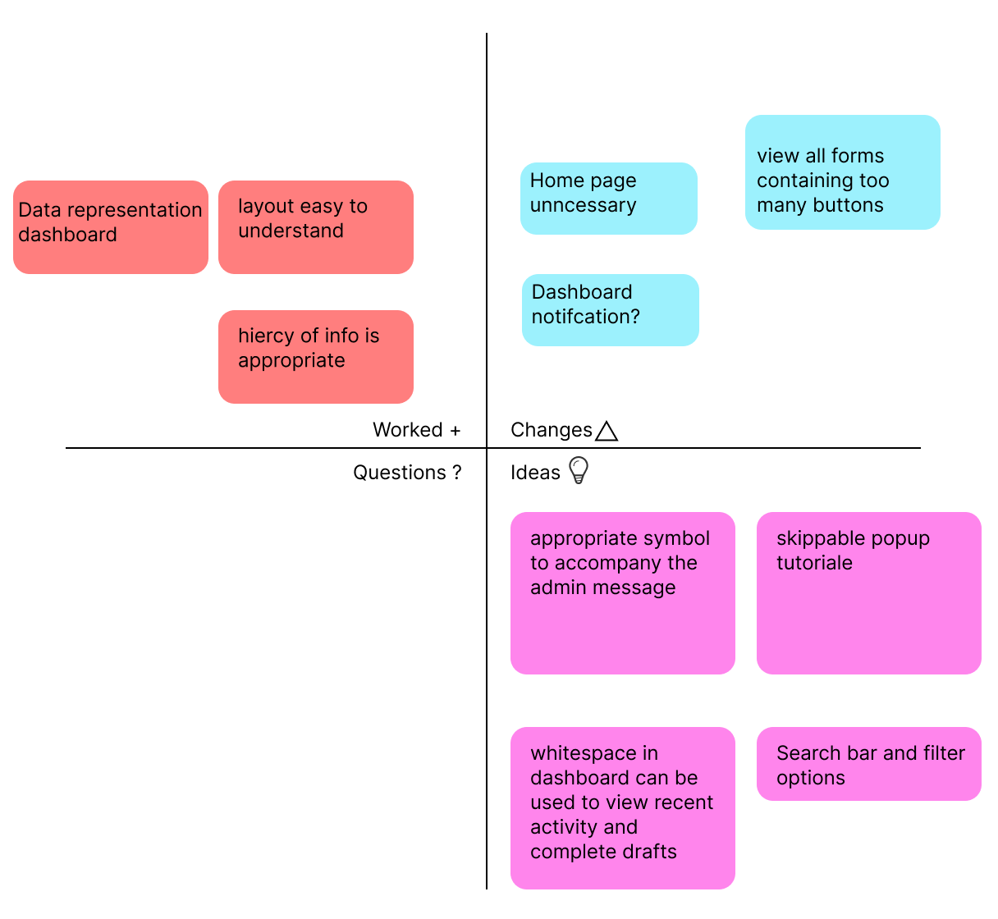

**Iteration 3-**

High fidelity MVP:  
[Link](https://www.figma.com/file/FbRSKh3xxtsCRjSkC5XZjb/high-fi?type=design&node-id=0-1&mode=design&t=TKbdhOwQxJyLqq9k-0)

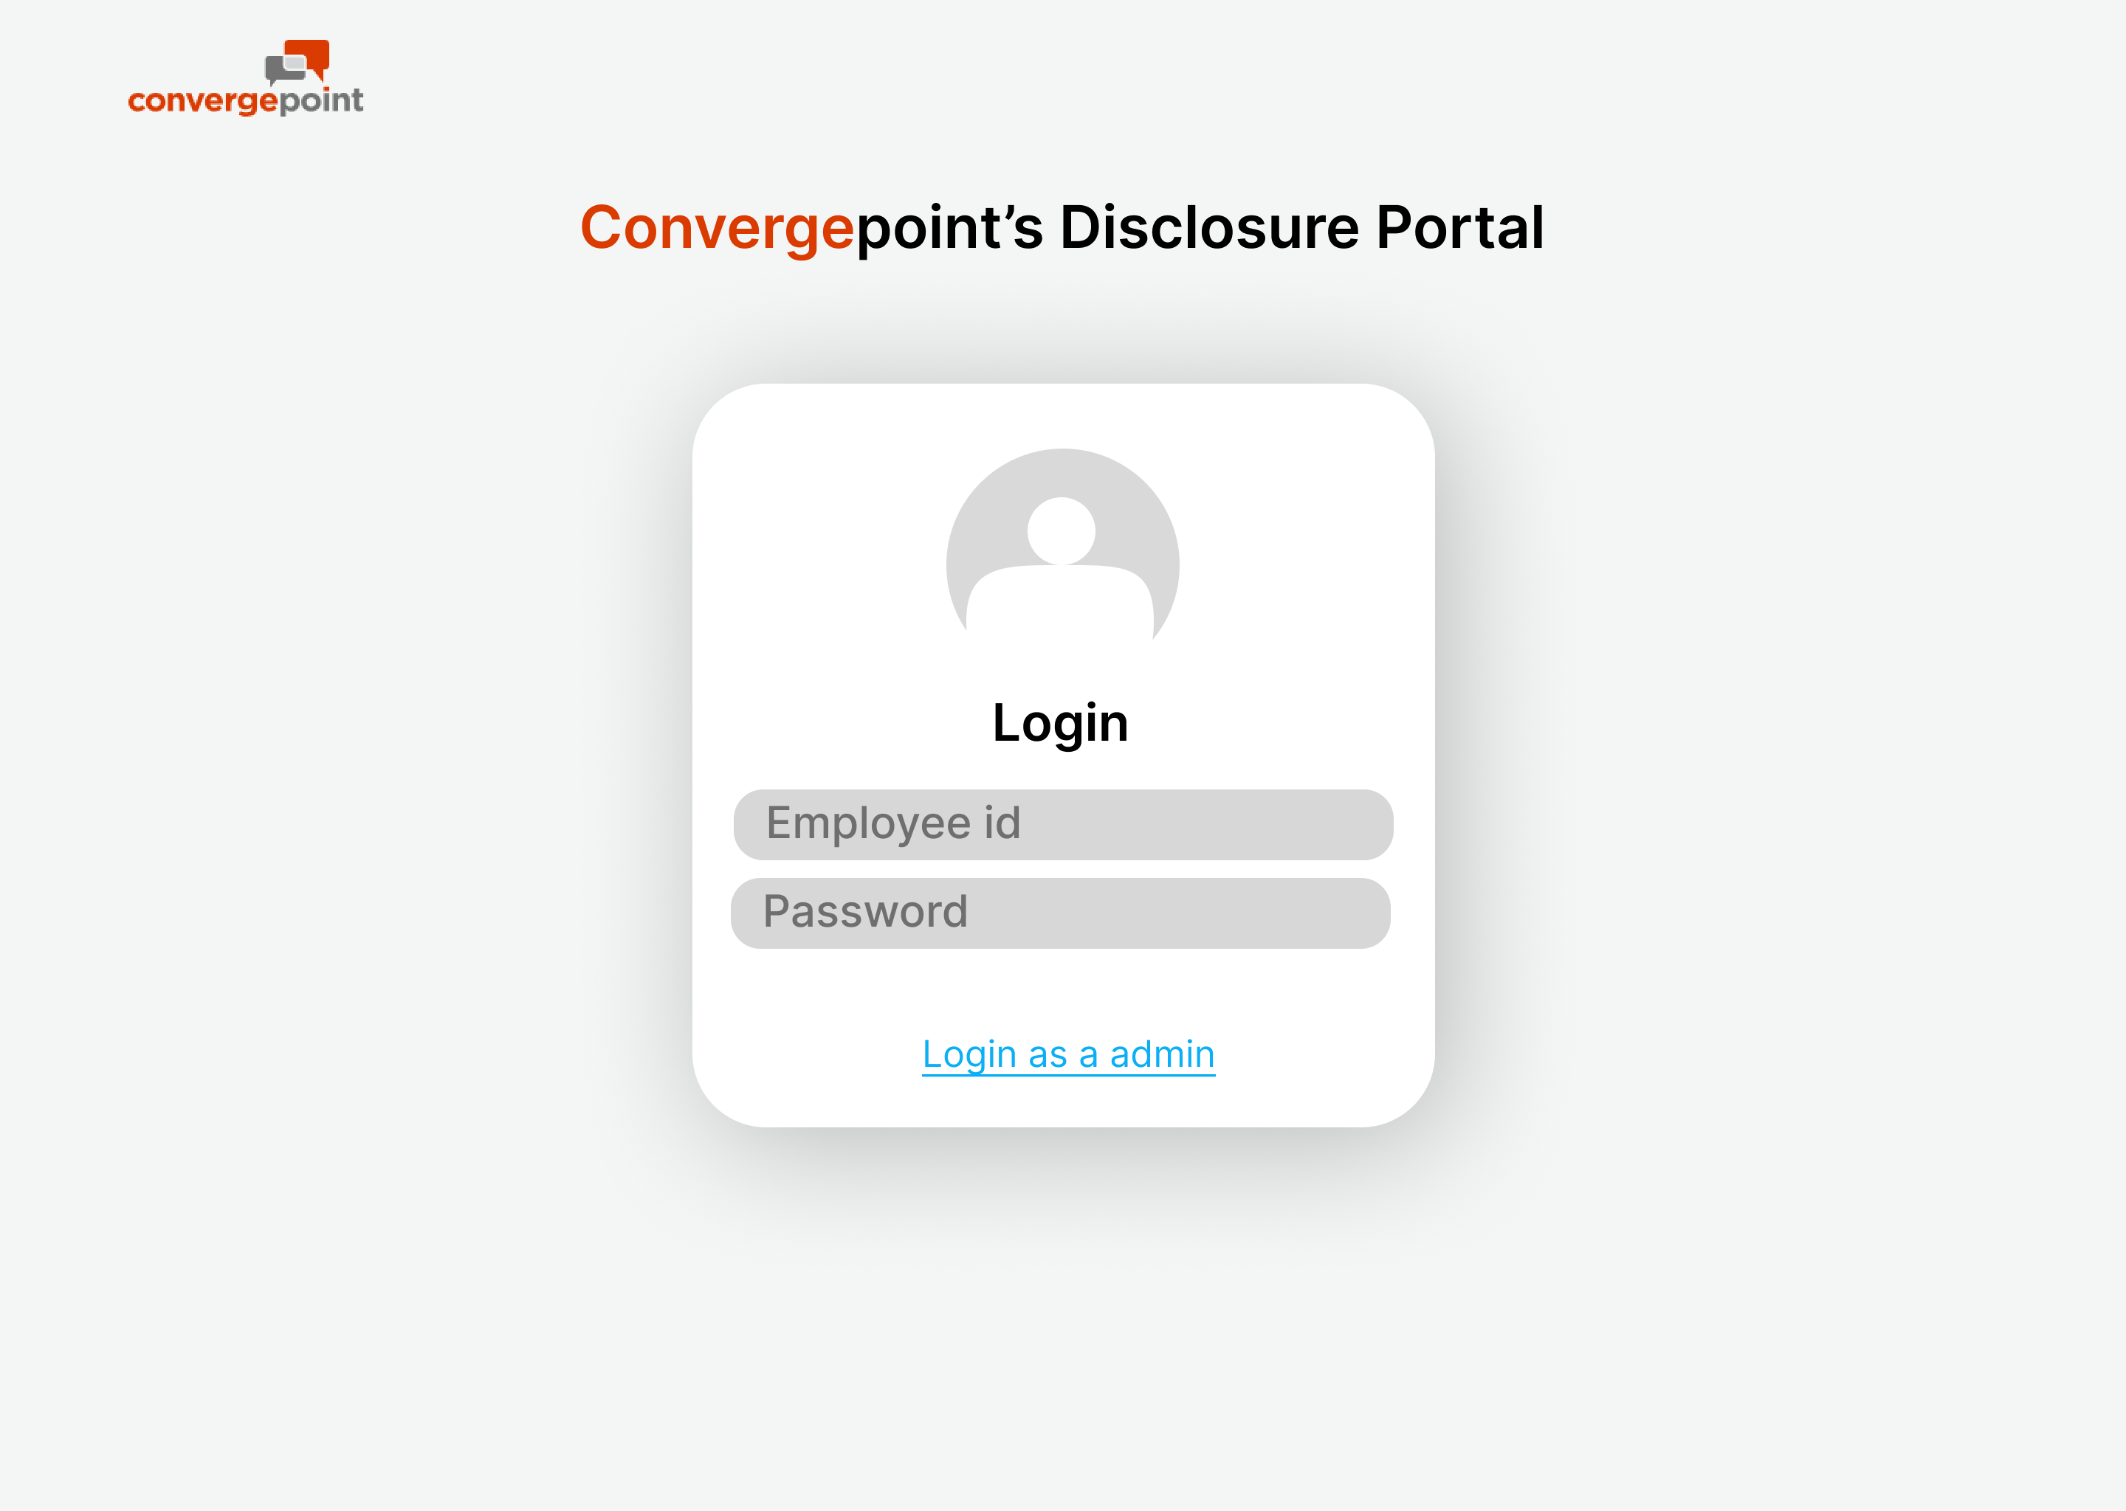 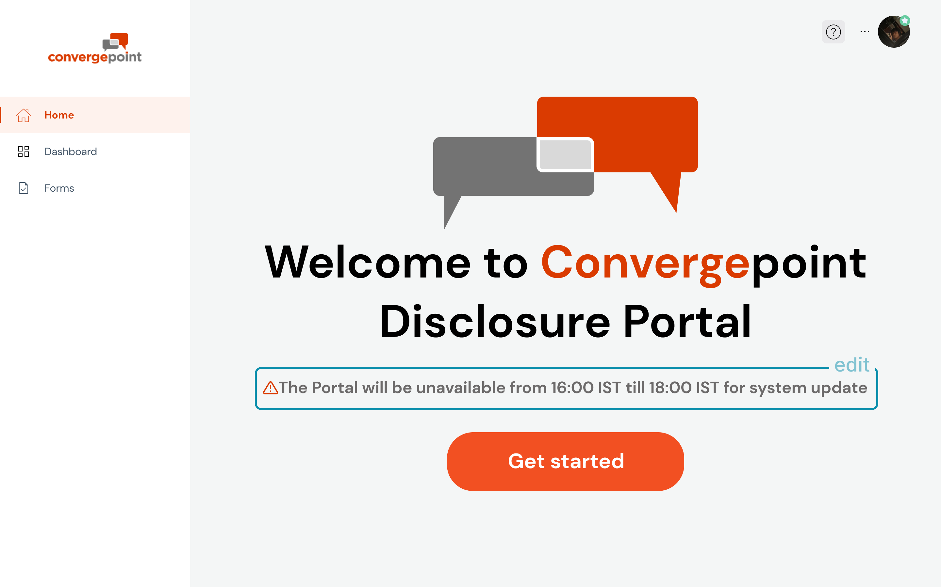 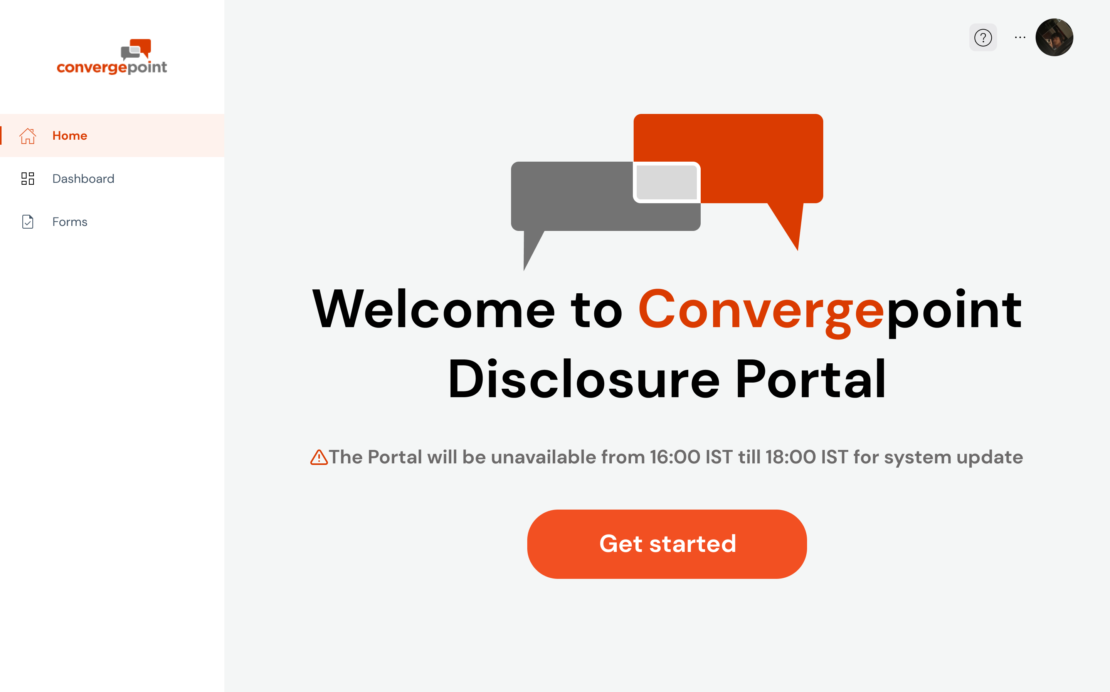 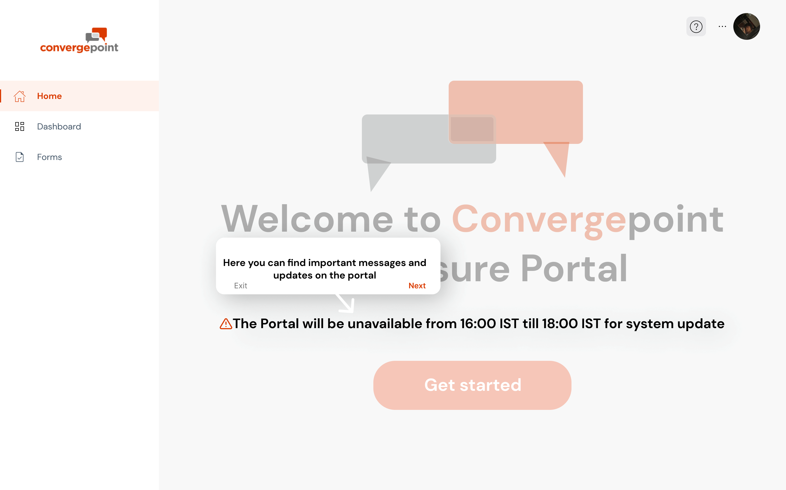 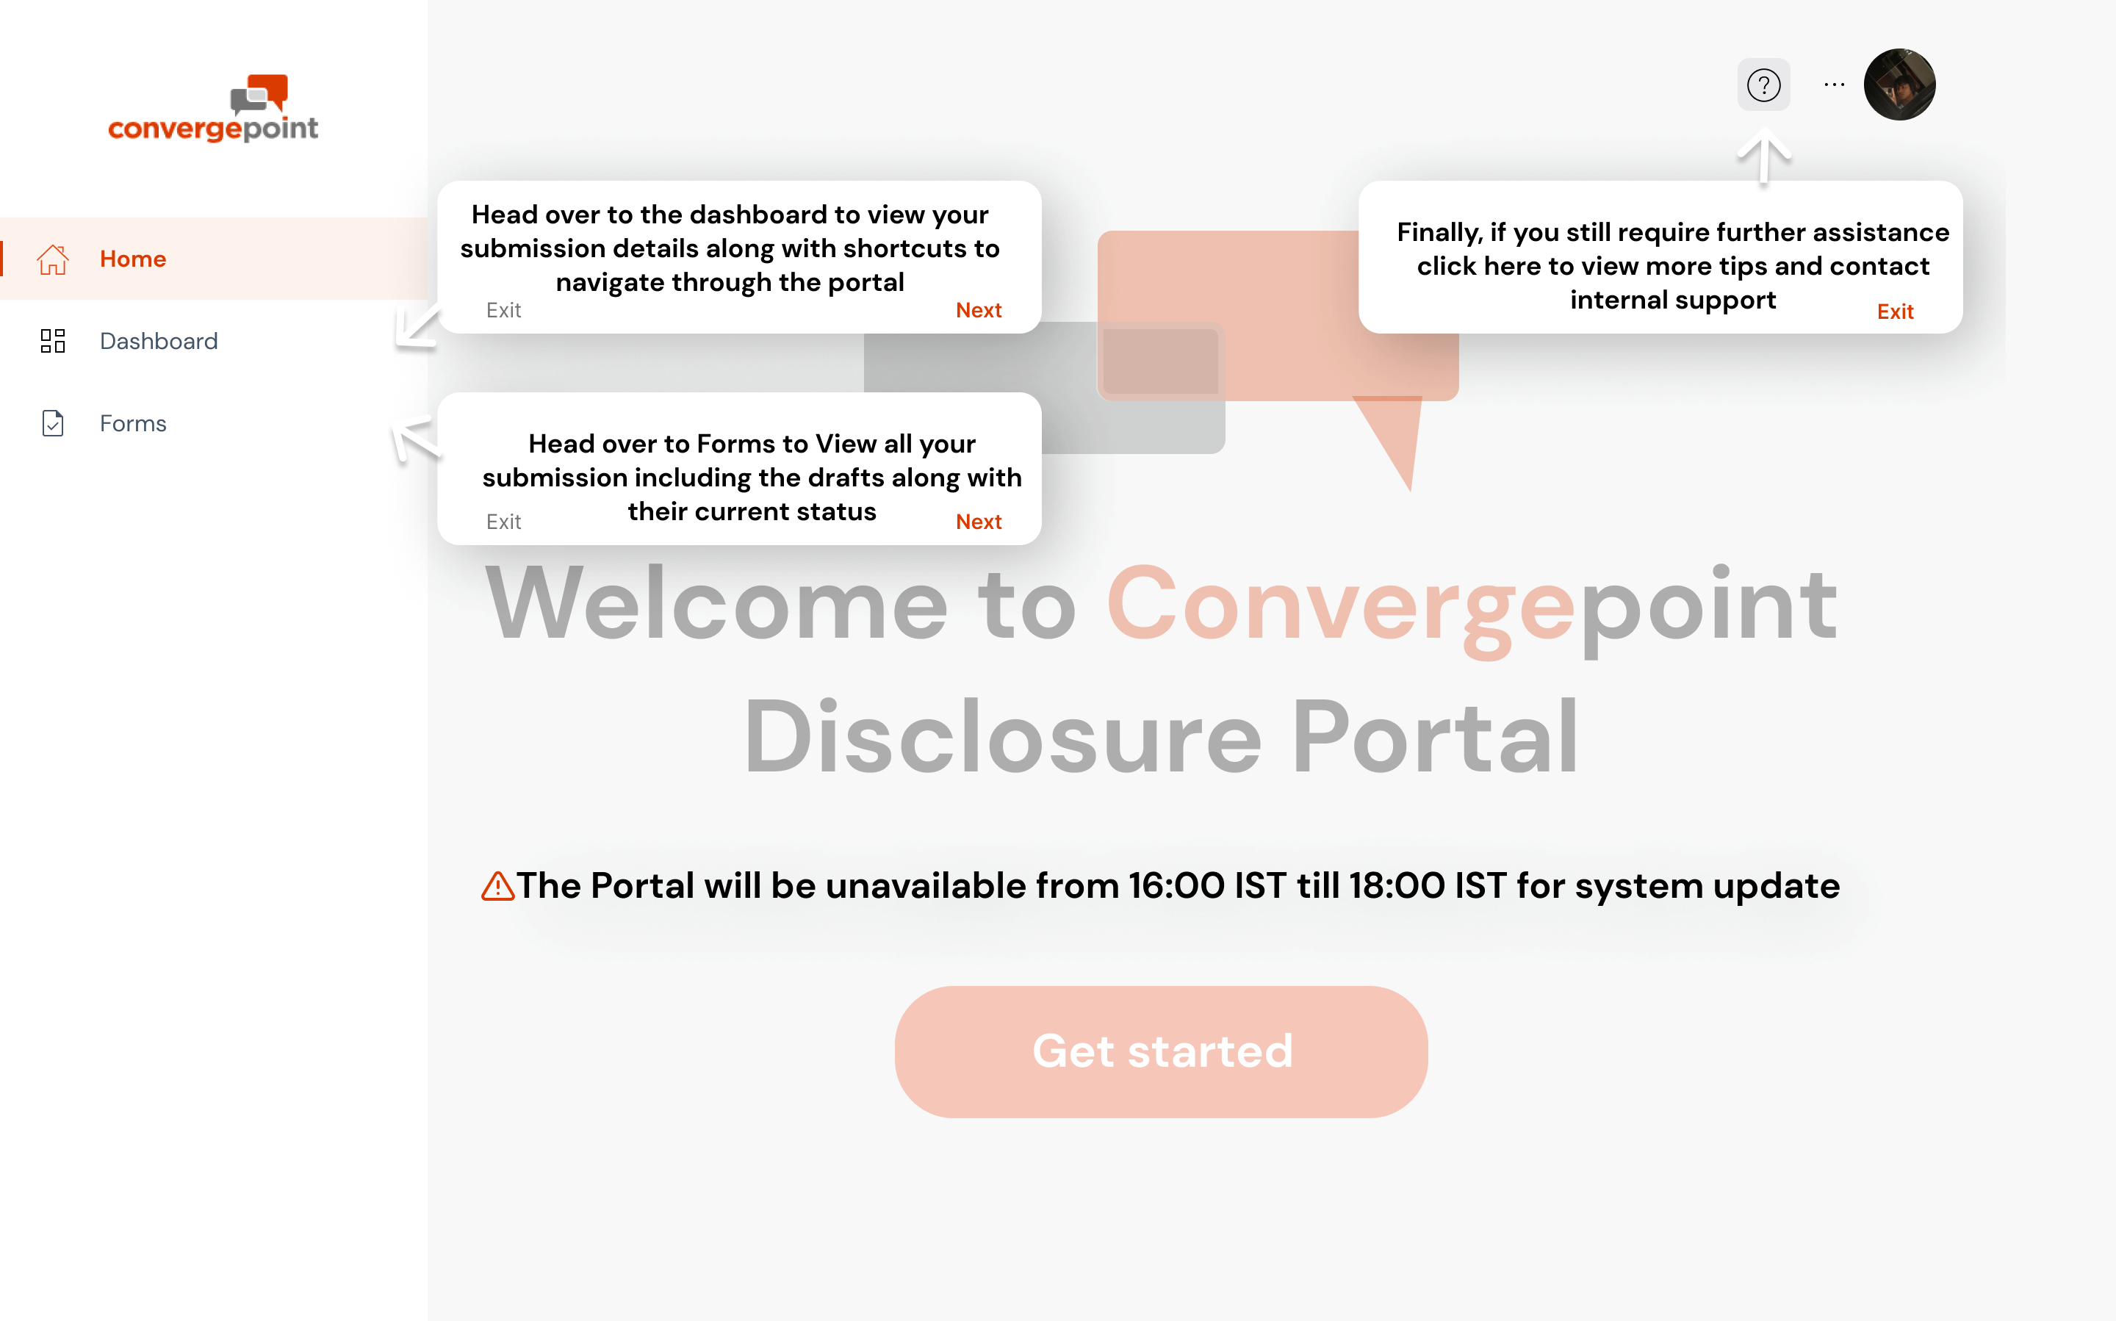 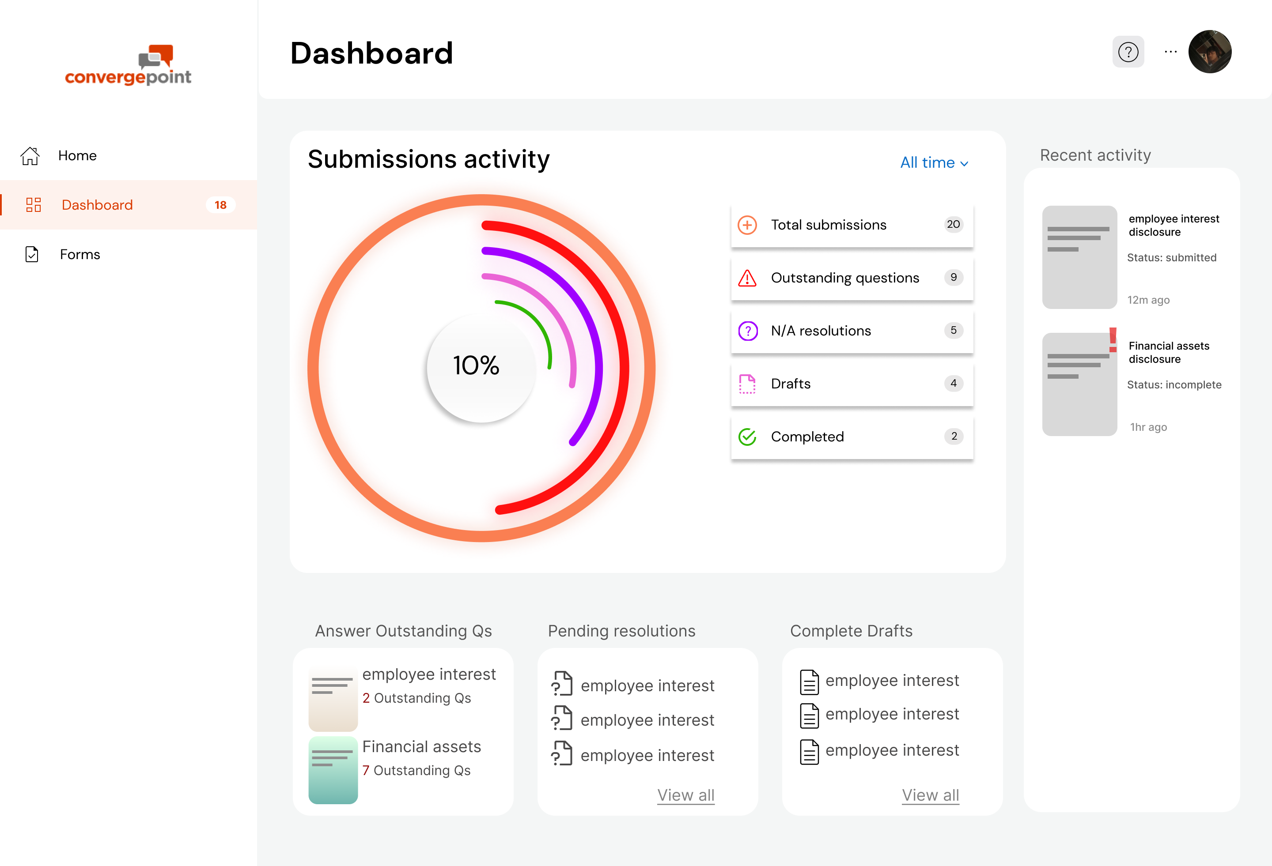 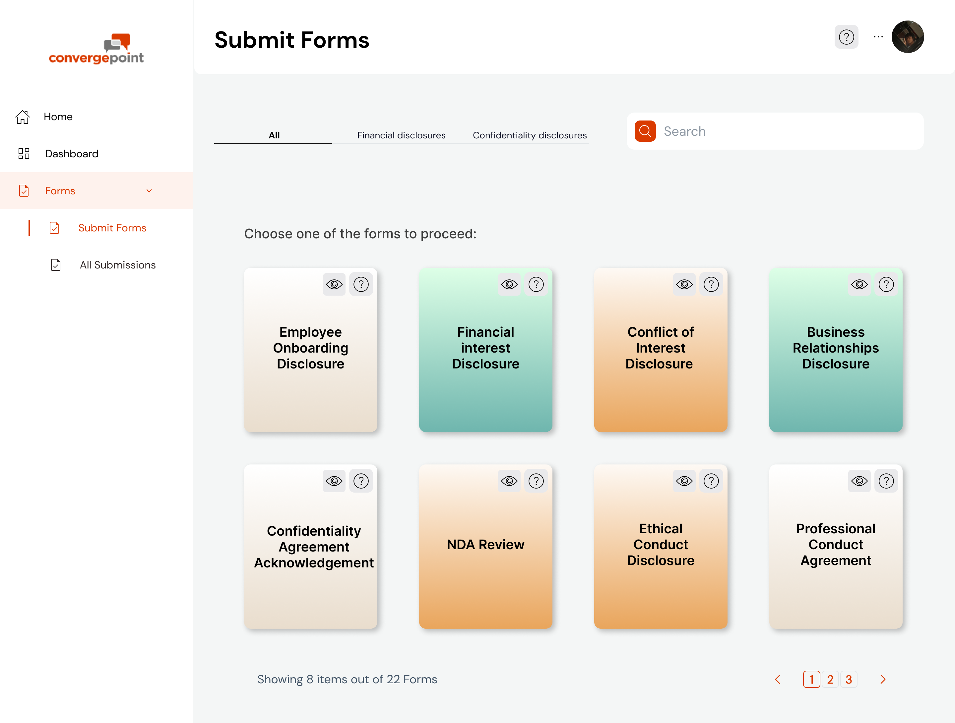   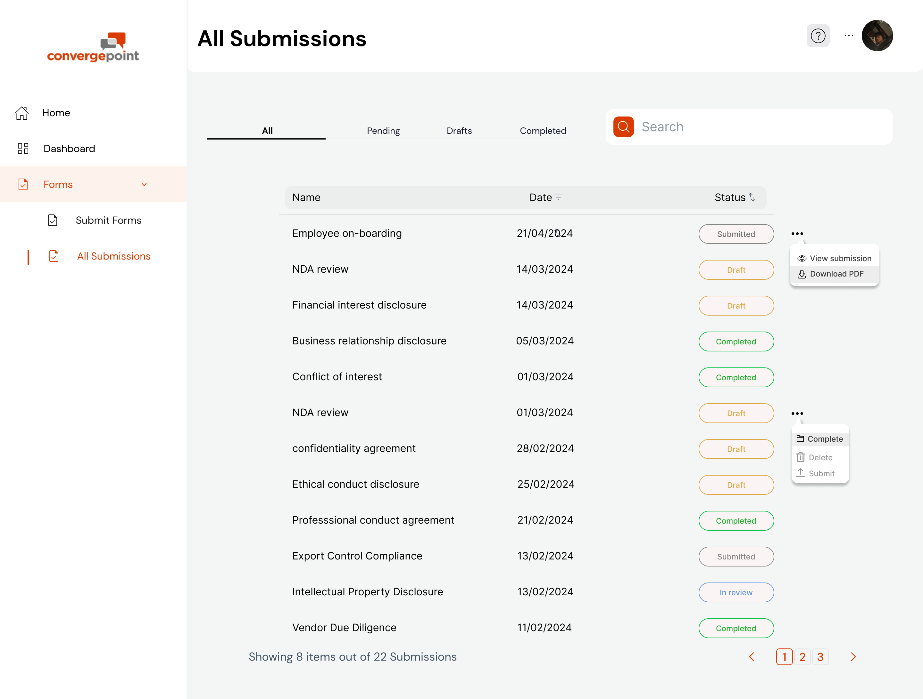

Figma links:

Low fidelity & Mid fidelity: <https://www.figma.com/file/GDYCqNu3x21Zqv8suEWIm4/Low-fid-and-mid-fid-convergepoint?type=design&mode=design&t=g0fWVaK9LZFtdUvP-1>  
  
High fidelity: https://www.figma.com/file/FbRSKh3xxtsCRjSkC5XZjb/high-fi?type=design&mode=design&t=g0fWVaK9LZFtdUvP-1   
  
personas, storyboards and feedback grids: https://www.figma.com/file/SG22QQWCqFUGiNci9K56JM/Untitled?type=design&mode=design&t=g0fWVaK9LZFtdUvP-0

References  
<https://www.capterra.in/software/1008175/pentana-disclose#reviews>  
<https://www.capterra.in/software/130831/certent-disclosure-management>  
https://www.g2.com/search?utf8=%E2%9C%93&query=disclosure